MINECOFIN Quarterly Macro-Fiscal Outlook—2023-27

Background
This Outlook analyzes recent developments and the short- to medium-term outlook for key macro aggregates (16 quarters ahead), considering macro policies and policy responses to new developments and shocks. It interprets the transmission mechanisms of shocks and policies, with emphasis on fiscal variables and MINECOFIN’s concern about stabilizing output, maintaining levels of living, and keeping the longer-term growth potential.
The underlying macro model is a New-Keynesian semi-structural ‘gap model’ which traces key macro variables—output, inflation, exchange rate, and interest rate—in deviation from their potential or trend levels. After shocks and policy responses have worked out, all variables return to their trend path which converge to their steady-states levels, determined outside the model (e.g., potential GDP growth, CPI target, real interest rate, real exchange rate depreciation rate, etc.). The model captures fiscal, monetary, and exchange rate policies—with policy rules and scope for discretion—with a view to enhancing policy coordination.
The model is distinct from other FPAS models as used by central banks in several ways: the elaborate fiscal block with deficit and its constituents (revenue, spending on goods and services, other spending) and their discretionary, cyclical, and structural components; the breakdown of demand into five components each with its own equation; and the derivation of variables in levels.
Section I reviews recent macro developments (16 quarters past), interprets updated trends and gaps for key macro variables, e.g., output, RIR and RER (using data for 2006-23. Section II assesses the policy stance and initial conditions for the forecast. Section III provides forecasts (16 quarters ahead) given exogenous external variables, expected fiscal policy stance, and near-term/judgmental forecasts. Section IV compares results with the macroeconomic framework and discusses an alternative scenario with slower declines in world food and oil prices, and possible policy responses.

Summary Outlook (to update)
- Inflation (CPI headline, y-on-y %) is expected to have peaked at 19% in Q4 2022 and to gradually fall in 2023 (to 12% in Q2 and 6% in Q4), as food and energy prices started falling from Q4 2022 and Q1 2023, resp., inflation shocks prove temporary, and inflation expectations are countered by NBR actions. From 2024, inflation should be close to the official 5% target.

- GDP growth should pick up in 2023-24 to just above 8% as the remainder of the Covid-induced output gap (GDP estimated at 4% below potential at end-2022) is absorbed. It is helped by still low, though increasing real interest rates (RIR), rising real exchange rates (RER), still favorable (though declining) fiscal stance. From 2025, growth should return to its steady-state path, estimated at 7.5% annually.

- The current positive fiscal impulse—equivalent to over 2% of GDP in FY 2020/21-2022/23—is projected to end in 2023, and so will its output stabilizing effect. In general, a 1% of GDP higher/lower deficit raises/lowers real GDP by ¾%, of which two-thirds the direct effect of government demand for goods and services and one-third the indirect effect on private demand (both net of imports).

- The RIR (interbank rate minus one quarter ahead CPI-core) is forecast to rise, albeit from a negative level (-3% in mid-2022), turn positive though still below trend in Q2 2023, and exert less and less upward pressure, then downward pressure on private demand.

- The RER (relative to CPI-core) is forecast to rise from a low, negative level and exert less and less downward pressure, then upward pressure on private demand (net exports).

- Both these drivers of private demand are influenced by the NBR for output stabilization reasons, while steering them to their trend and steady-state paths, estimated at 2.5% for the RIR (country risk 2%, foreign RIR 0.5%), and at 0% for the RER depreciation rate.

- Given uncertainty on the external environment, forecasts are subject to higher-than-usual errors. A scenario with slower declines in world food and oil prices entails a slower return to normal inflation.

MINECOFIN Quarterly Macro-Fiscal Outlook—2023-27 1
I. Recent macroeconomic developments, 2019-23 4
A. External environment 4
B. Output and final demands 4
C. Fiscal policies and government demand 7
D. Inflation and its components 10
E. Nominal/real interest and exchange rates 12
II. Current macro policy stance and initial condition (EvM) 15
A. Current cyclical position 15
B. Fiscal policy stance 15
C. Monetary and exchange rate policy 15
III. Macroeconomic outlook, end-2023─2026 17
A. Forecast assumptions 17
1. External environment assumptions (WEO and other sources) 17
2. Domestic environment assumptions 18
3. Fiscal policy assumptions 18
B. Summary of macroeconomic forecast 19
C. Macroeconomic forecast narrative 20
1. Output (GDP) and cyclical position 20
2. Private final demands and cyclical positions 22
3. Government demand and deficit components 24
4. Inflation (CPI) 27
5. Policy interest rate and real interest rate (model uses IB rate) 30
6. Exchange rate (ER) and real exchange rate (RER) 32
D. Summary of policy stance and forecast 34
IV. Supplementary information 36
A. Comparison with Macroeconomic Framework projections 36
B. Alternative scenarios and policy responses 37
1. Scenario of higher foreign food and oil prices in 2023-24 37
2. Possible domestic policy response 38
Annex 1. Rwanda Quarterly Macro-Fiscal Model (QMFM) main features 39
Annex 2. Model calibration/filtering using model properties and historical data (2006-22) 44
Annex 3. Recent developments of other final demands and decomposition (2015-23) 46
Annex 4. Fiscal block: deficit, fiscal policies, and fiscal impulse in the model 49

Recent macroeconomic developments, 2019-23
This section assesses recent macro developments since just before Covid using a macro model. The model identifies the drivers of key macro aggregates, is calibrated to fit the data for 2006Q1-2023Q2 and to obtain plausible trends and other unobserved variables using exogenous information and judgment for various parameters, and provides the initial conditions for the forecast.

External environment
Rwanda’s external environment in 2021-23 was overall less favorable than in 2019-20, with favorable factors more than offset by unfavorable ones. With increases in import prices far exceeding those in export prices, the commodity terms of trade fell significantly over the period (Table 1).
Table 1. Rwanda’s external environment in recent years, y-on-y % growth (unless indicated otherwise)
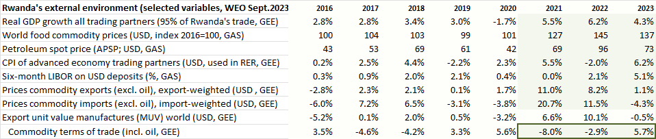
On the favorable side, trading partner demand grew at over 5% p.y., from less than 1% on average in 2019-20, narrowing the negative foreign output gap relevant for exports, but boosting mainly tourism and a few commodity exports. International interest rates were below 2% until 2022 when they started to increase as monetary policies tightened around the world to combat inflation induced by post-Covid pent-up demand, supply chain disruptions, and the war in Ukraine. However, interest rates remained negative in real terms.
Prices of Rwanda’s exports rose much in 2021-23 (coffee, tea, metals), but sharp increases in import prices more than offset the favorable export prices. Petroleum import prices doubled during 2021-22 and stayed high in 2023, and world food prices rose steeply from early 2021 and were some 40% above their 2019-20 level during 2021-23. Manufacturing prices also rose due to supply bottlenecks. Thus, Rwanda’s import prices as measured in WEO-GEE rose sharply in 2021-22 before stabilizing in 2023. As a result, the commodity terms of trade fell by a cumulative 6% during 2021-23.

Output and final demands
Output. Real GDP growth averaged 7½ percent during 2000-19. Growth was above average—and output estimated to be a bit above potential—in 2019. Under Covid, Rwanda’s economy contracted in 2020Q2 (total lockdown), and y-on-y growth was negative in 2020Q2-4 (-12%, -4% and -1%) as supply constraints and external and domestic demand drops lowered production. In 2020, GDP dropped by -3.4% and was almost 12% below the potential level had growth continued normally. Expansionary fiscal policies from 2020Q2 mitigated losses in income and consumption of households and enterprises and helped contain GDP losses in 2020 and the subsequent recovery. Despite the strong bounceback in 2021, output is estimated to have remained below trend level since then, as global instability related to the war in Ukraine slowed down recovery from 2022Q1 onward (Figure 1.1). Although it is difficult to assess potential GDP when large shocks like Covid may leave permanent scars to production capacity, GDP is estimated to be almost 7% below potential in mid-2023.
Consumption is about three-quarters of GDP, and the drop in consumption accounts for a large part of the down pull of GDP levels since Covid (Figure 1.2-3). The drop in imports during Covid due to both supply constraints and lack of demand, constituted a favorable shift toward domestic demand and offset somewhat the down pull effect of lower exports and investment. Consumption and investment recovered quickly, but exports remained sluggish until early 2022.
Figure 1. GDP-output: growth, gap and components, 2015-23
Fig. 1.1 Output growth y-on-y and trend, %  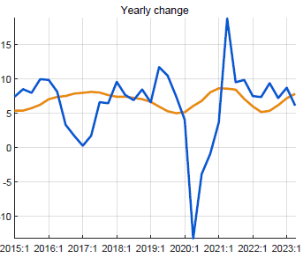 | Fig. 1.2 Output growth by demand component
Covid years (2020-21)  - consumption and investment account for most of the GDP drop and output gap  - fall in imports and expansionary government demand helped mitigate the downpull on GDP  Immediate post-Covid (2021-22)  - consumption and investment contributed most to the recovery  - supported by continued government demand, while exports remained sluggish  Ukraine-war (2022-23)  - post-Covid recovery slowed down due to jumps in international oil and food prices, causing high inflation and drop in real consumption and other demand  - fiscal consolidation started (but in part thwarted by floods) reduced expansionary effect of govt demand on GDP | Fig. 1.3 Output gap (vis-à-vis trend) and components  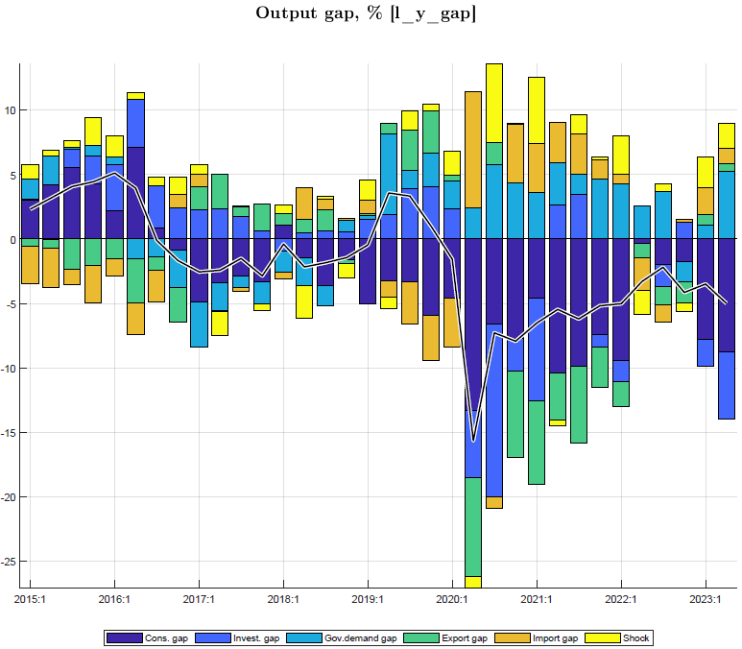
Consumption. Private consumption shows strong fluctuations in part due to its residual nature in national accounts estimate. During the 2020-21 Covid years, the drop in private consumption due to lockdown and ensuing income losses (multiplier effects) featured the largest shocks (in % of GDP) of all final demands. The adverse impact was exacerbated by the relatively high RIR (until mid-2021 as inflation was very low, with nominal interest rates quasi-constant), but partly offset by fiscal expansion (see below) (Figure 2). The upturn in consumption was uneven as Covid impacts resurfaced and the Ukraine war in early 2022 interrupted the post-Covid economic recovery. By end-2022, consumption had returned to normal, but dipped strongly in early 2023 for inflation eroded purchasing power.
Figure 2. Consumption: growth, gap and components, 2015-23
Fig. 2.1 Consumption level (l_cons) and trend  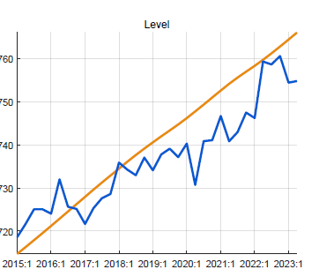 | Fig. 2.2 Consumption gap (vis-à-vis trend) and components  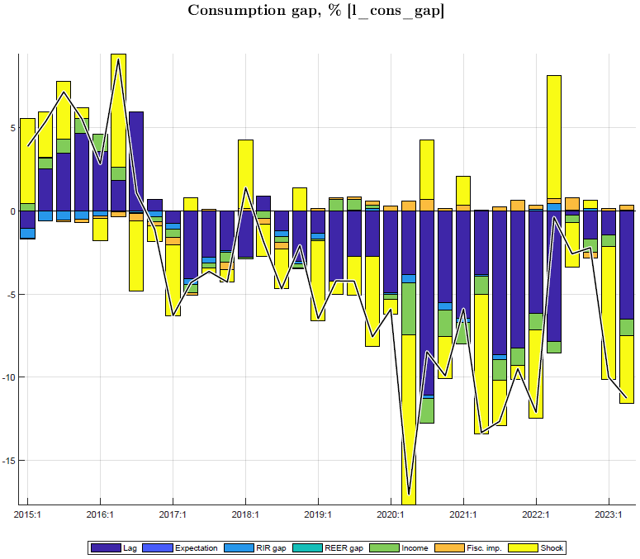

Fiscal policies and government demand
Fiscal policies affect output directly as government spends on G&S and—to a much smaller extent—indirectly as fiscal deficits affect incomes and hence private demand. This study traces both effects separately, by describing each of the deficit constituent parts (revenue, spending on G&S, other spending) and their discretionary, cyclical, and structural components, all expressed as ratios of GDP since fiscal policies are mostly conceived that way. The deficit fluctuates over time around its trend—determined by longer-term financing constraints—mainly due to discretionary spending in response to crisis and to a lesser extent due to variations in other spending and revenue in line with the business cycle. For each constituent part, the components are distilled from the data by identifying movements with the business cycle and trends. The components of the deficit are the sums of the components of the constituent parts; e.g., the cyclical deficit is cyclical spending on G&S plus cyclical other spending minus cyclical revenue.
The deficit has fluctuated around 11% of GDP in the last 8 years, but was higher in Covid years, mainly due to higher spending on G&S as a ratio of GDP (Figure 3.1). The structural deficit—deficit before grants corrected for cyclical and discretionary components which cancel out over the business cycle—has trended slightly downward over the last 8 years (from 14 to 12% of GDP), as access to financing and infrastructure investment declined. The discretionary deficit is mainly driven by government discretionary spending, notably on G&S and was large during Covid, and declined thereafter. The cyclical deficit is very small, driven by cyclical other expenditure (transfers and subsidies to households and enterprises) and revenue collection, which as a ratio of GDP increase and decrease, respectively, with a downturn (and vice versa with an upturn) (Figure 3.2).
Sentence on calibration of pars (incl SDs) of deficit components to obtain plausible patterns for each
Fig. 3.1 Fiscal deficit: revenue (-), spending G&S (+), and other spending (+), % of GDP  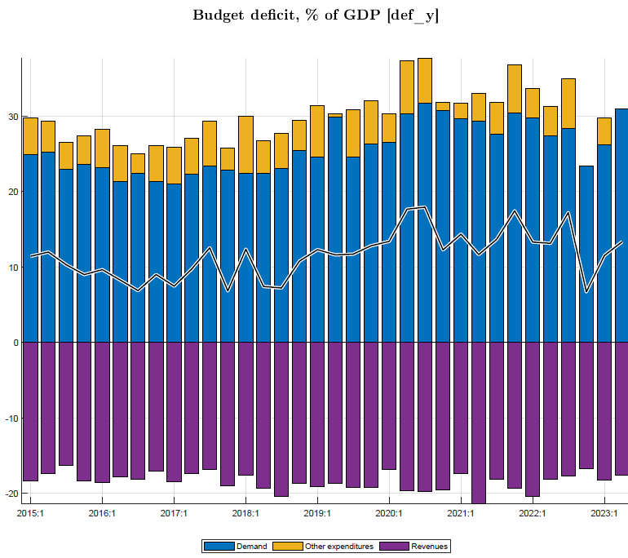 | Fig. 3.2 Fiscal deficit: structural, cyclical, and discretionary, % of GDP  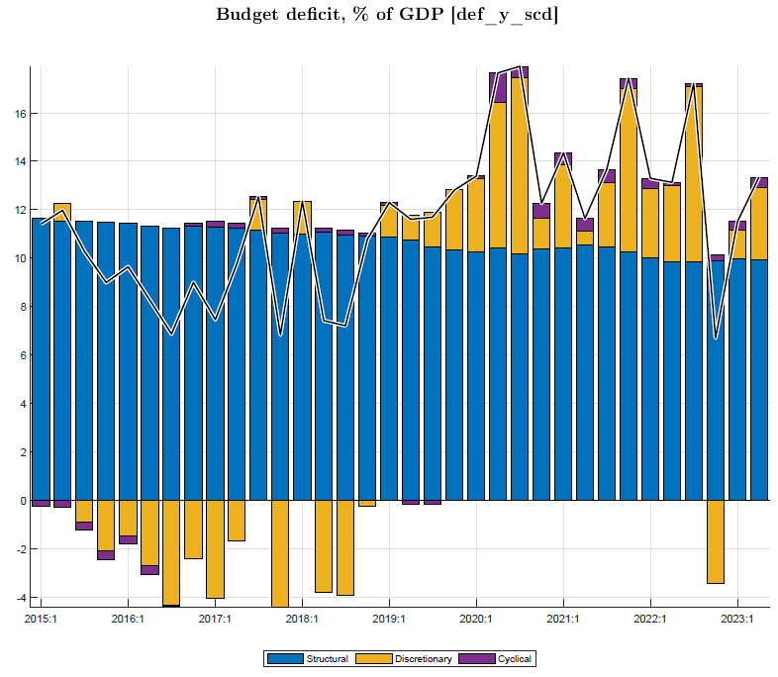

Tracing the deficit and its parts and components serves to distil government demand for G&S and the fiscal impulse, as both play key roles in the effect of fiscal policy on output during the business cycle.
Government demand—defined as spending on G&S for consumption and investment, 24% of GDP in 2006-23—has a direct effect on demand and output and—of all fiscal policies—has the largest effect on output as well on the fluctuations in the deficit. The trend in govt demand is considered the same as structural government demand (in % of GDP times trend GDP), and thus government demand above (below) trend—that is discretionary plus cyclical spending—affects output in the business cycle. As those policies are expressed as ratios of GDP, a positive (negative) output gap itself raises (lowers) govt demand.
Thanks to Covid-response measures spanning fiscal years 2019/20-2021/22, government demand was well above its trend level during most of 2020-22 (on average by over 2% of GDP) and helped counter the Covid-induced output drop (Figures 1.3 and 3.3). Govt demand in deviation from its trend or structural level reflects mainly discretionary spending (Figure 3.4).
In the years before Covid, govt demand had been below trend [mainly due to a decline in foreign-financed investment projects]. After the expansionary Covid response, however, from late 2022, government demand went into reverse as the deficit was reduced to bring down debt that had risen rapidly in the previous years. At the same time, surging inflation further reduced government demand in real terms. However, in the first half of 2023, govt demand was raised in response to the flooding crisis. Yet most of the increase in govt demand in 2023Q1-2 seems an artefact due to likely large overestimate by National Accounts of govt consumption, since 2021 perhaps by considering a good chunk of capital spending (NANFA) as consumption. This needs verification/correction, also undoing the now anomalous reduction of other expenditure (calculated residually after gdem for G&S).

Figure 3. Government demand: as ratio of GDP and gap vis-à-vis its trend, 2015-23
Fig. 3.3 Govt demand for G&S, % of GDP  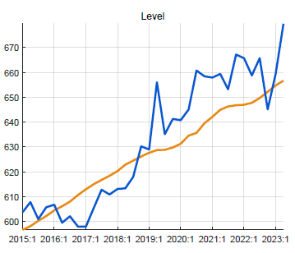  - government demand was below trend level during 2015-19 as [investment was cut]  - during Covid years, government spending shot up, esp. on health and education  - this government spending contained the downturn induced by Covid lockdowns | Fig. 3.4 Govt demand gap (vis-à-vis trend) and drivers, %  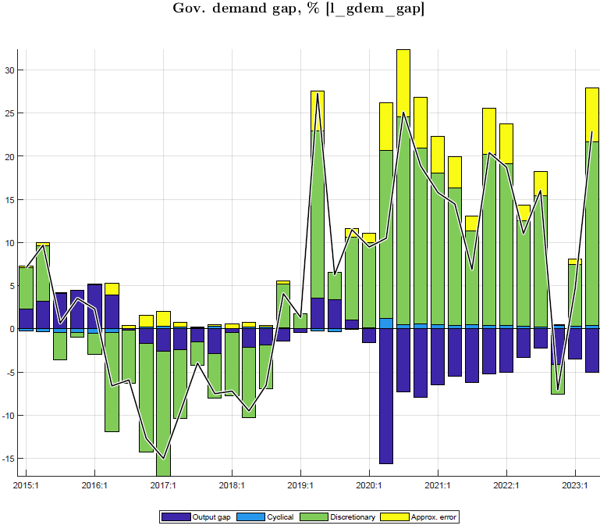

Fiscal impulse. As noted above, this study separates the direct effect of govt spending on G&S on demand and output from the indirect effect of a change in fiscal policy (as gauged by the fiscal impulse) on private consumption and investment. The fiscal impulse was on average about 2% of GDP during Covid years 2020-22 (Figures 3.5).
The fiscal impulse was largely reversed as fiscal consolidation took hold from late 2022, but consolidation was in part interrupted by the flood crisis in 2023Q2. The discretionary deficit is the main driver of the fiscal impulse to private demand, together with the change in the structural deficit which is very small. The discretionary deficit affects private demand because other expenditure (transfers, subsidies, net lending) and lower revenue collection increase disposable incomes, while discretionary govt demand for G&S boosts private sector spending optimism.
Fig. 3.5 Fiscal impulse, % GDP  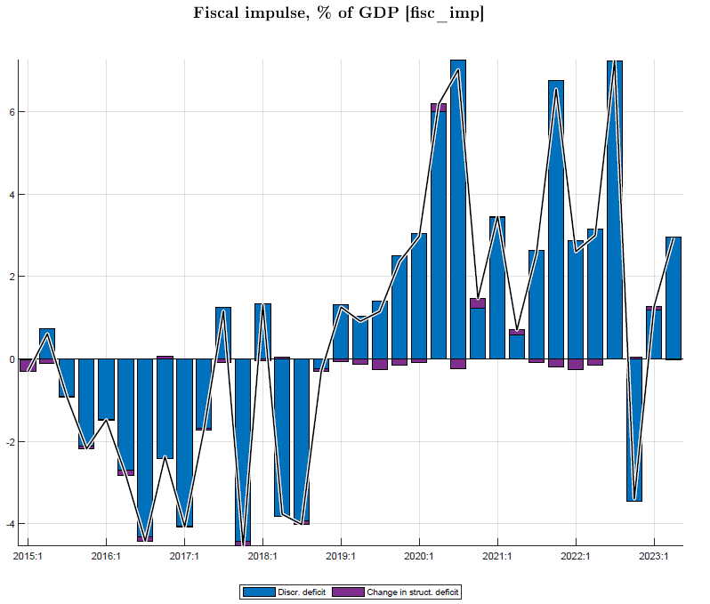 | Fig. 3.6 Fiscal impulse (via private demand) on output vs govt demand effect on output, % GDP

The combination of government demand (affecting output directly) and fiscal impulse (affecting private demand, and output, indirectly) makes for an important short-term impact of fiscal policy. An increase in the deficit equivalent by 2% of GDP—as was effected during Covid—raises real GDP by some 1.6% point: by 1.2% point directly and by 0.4% point indirectly via the fiscal impulse to private consumption (0.3%) and investment (0.1%), after netting out import shares in each demand.

The other final demand components—private investment, exports, imports—are discussed in Annex 3.

Inflation and its components
Inflation in Rwanda is characterized by high volatility, mostly driven by factors unrelated to the business cycle. The main factors are weather-induced fluctuations in harvests and agricultural prices, openness and dependence on imports, especially for food and petroleum products with volatile international prices, and lack of competition in many markets. Food and energy price increases are often transmitted to increases in domestic core prices, so that food and energy prices contribute to volatility of headline inflation both directly and indirectly. The recent Covid and Ukraine crises underline the vulnerability to domestic and external price shocks as weak harvests and soaring domestic agricultural prices coincided with surging world food and energy prices (Figures 4.1-2).
Figure 4. CPI Headline and components, y-on-y %, 2006-23
Fig. 4.1 CPI core, food and energy: historic volatility | Fig. 4.2 CPI headline and trend, y-on-y %  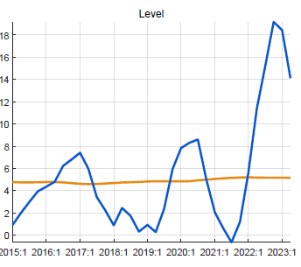
With a 16% weight, food price fluctuations contribute much to those in headline CPI, while energy with a 7% weight contributes much less (Figure 4.3). The relative price of food appears to be on an upward trend (Figure 4.4).
Fig. 4.3 CPI headline components  (weighted with shares in CPI basket)  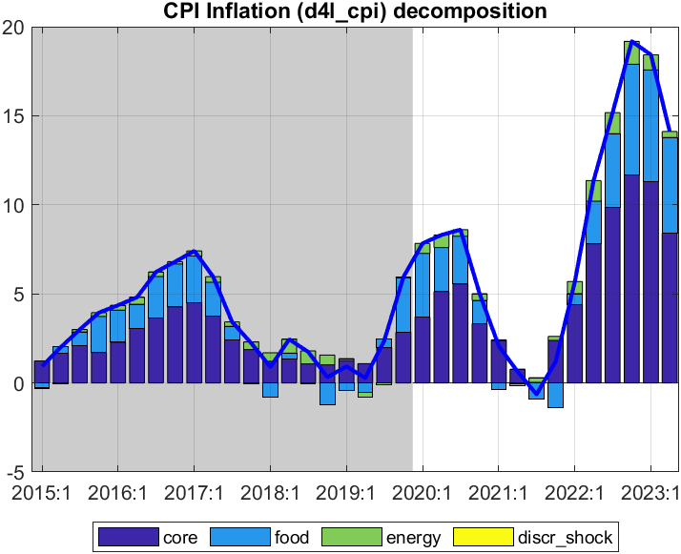 | Fig. 4.4 Relative price of food, vis-à-vis CPI headline 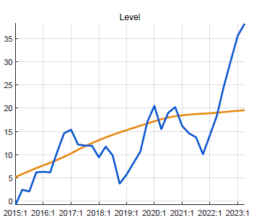
Core inflation is driven by a lag, expectations, direct import price effect, output gap and indirect import price effect (REER). However, it has large “unexplained” shocks, especially during Covid (negative shocks reflecting the lockdown) and the recent Ukraine-war induced inflation (positive shocks) (Figure 4.5-6). Thus a large chunk of the recent core inflation is not due to the standard factors, including the output gap. This implies that the core Phillips curve in Rwanda has only a weak relationship with the output gap and weakens the last step of the transmission of monetary policy, to real interest rates, to output gap, and to inflation.
Fig. 4.5 Drivers of CPI core inflation  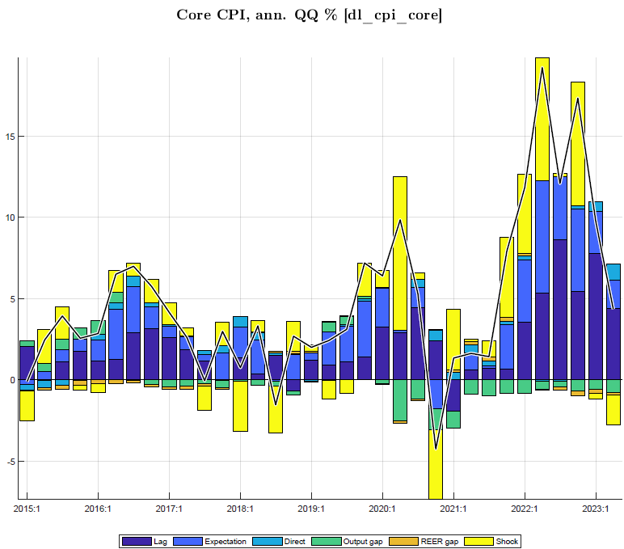 | Fig. 4.6 Direct effect foreign prices on CPI core  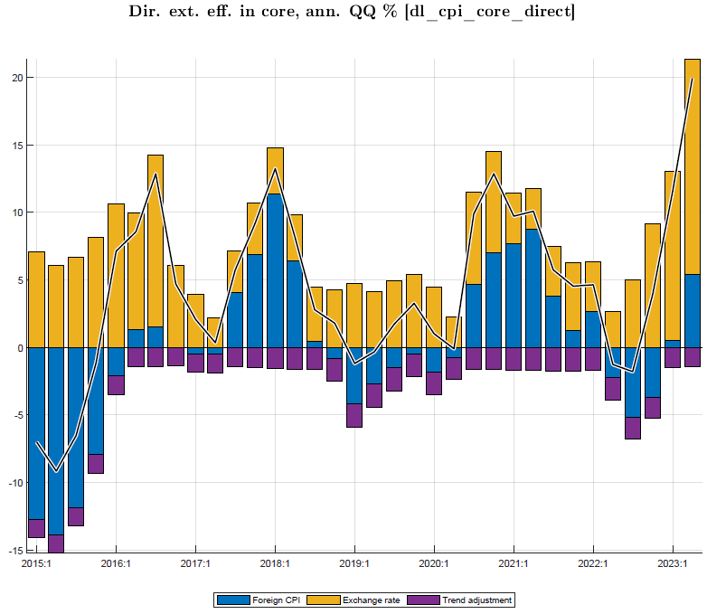
The drivers of food and energy are similar but with no impact of the output gap, with much larger shocks than for core CPI, smaller impacts of REER, and larger direct impacts of foreign prices. The CPI food is affected by the agricultural output gap (with negative sign) as good harvests mean lower agricultural food prices (Figure 4.7-8). The shocks for food and energy are downward in 2023Q1-2.
Fig. 4.7 Drivers of CPI food inflation  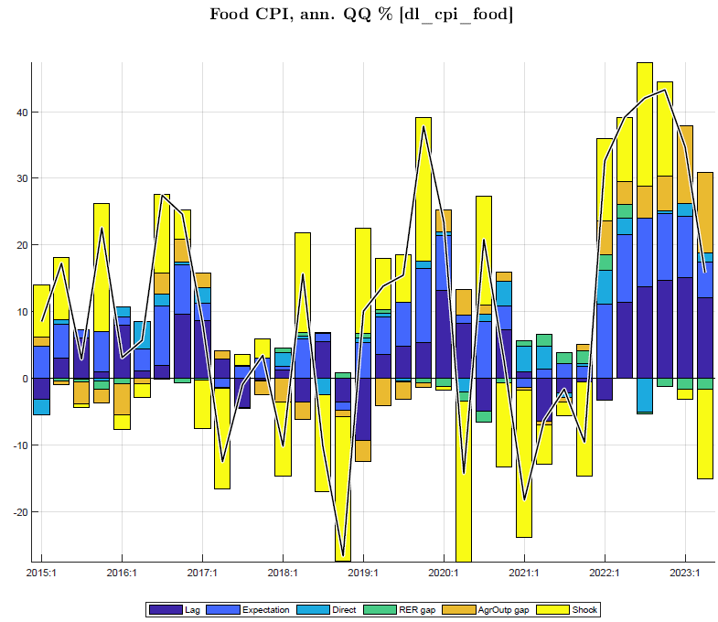 | Fig. 4.8 Drivers of CPI energy inflation  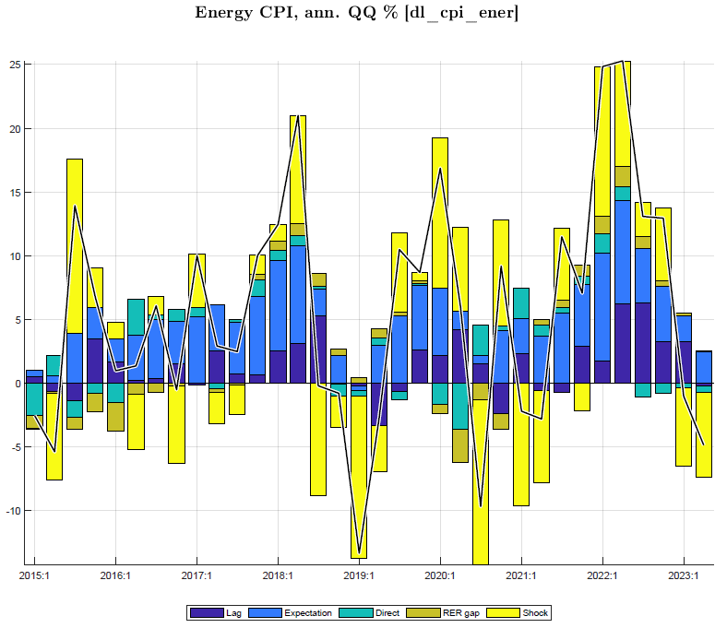

Nominal/real interest and exchange rates
The interbank interest rate (IB) is the key or “policy rate” the NBR seeks to influence through its Central Bank Rate (CBR) and is the indicator of monetary conditions, affecting the RIR and private demand. Since 2017 and especially through Covid years 2020-21, the IB was on a downward path and below its trend level of some 6.5-7%. Since 2020, IB and CBR rates have moved more closely, with IB some ½% points above the CBR. During 2020-21, despite low inflation and negative output gaps, interest rates were reduced little and were higher than the rates following from the Taylor rule followed by the NBR (Figure 5.3). In early 2022, in response to the surge in inflation, while the Covid-related negative output gap declined and was perceived to be small, the NBR raised ts CBR in five steps, starting in Febr 2022 from 4.5% to 5% and lastly in August 2023 from 7% to 7.5%, and the IB rates have followed closely (Figure 5.1).
The policy RIR (real interest rate, defined as IB minus core CPI{+1}) was below its trend level even negative in 2019 and early 2020. The RIR rose sharply during Covid 2020-21, when inflation was subdued and the IB was lowered only once, by 0.5% to 4.5% in April 2020, in response to the Covid downturn. However, since late 2021, as inflation surged (y-on-y from 1.7% in Dec 2021 to 17% in Dec 2022), the policy RIR and ensuing real lending rate have been falling sharply (Figures 5.2, 5.4).
Figure 5. Interest rates, RIR (IB and lending), and IB historic policy ‘rule’, in %
Fig. 5.1 Interbank and NBR interest rates | Figure 5.2 Interbank rate, RIR and inflation

The Taylor interest rate rule followed by the NBR has a relatively small positive (negative) response to output being above (below) potential and a high response to inflation being above (below) target inflation, of currently 5% for the CPI headline. As NBR moves interest rates gradually, the rule has a heavy weight for the lagged interest rate while trending back to the neutral rate (Figure 5.3). The lending rate has followed the interbank rate, but with a lag and a fairly constant spread of some 9%.
Fig. 5.3 Interest rate (IB) policy rule, components  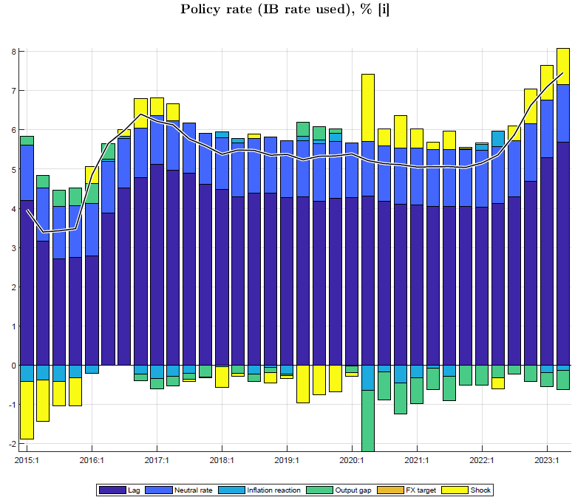 | Fig. 5.4 Real interest rate lending and IB, versus trends
Since mid-2022, the policy RIR has risen sharply as the nominal interest rates were moved up and inflation declined. The real lending rates followed, and after a low point of 7% in mid-2022 reached some 12% by the second half of 2023.

The NBR maintains a flexible nominal exchange policy with intervention to smoothen fluctuations. In practice, NBR’s ER policy can be described by a hybrid rule where the NER is steered such that the RER converges to an implicit target (driven by an exogenous steady-state RER depreciation path, while adjusting for domestic-foreign inflation differentials) and letting it somewhat respond to domestic-foreign interest rate differentials, adjusted for the country risk premium (Figures 6.1-2). Since late 2022, the NER depreciation rate has moved up sharply in line with the target NER depreciation rate—in turn adjusting for the high inflation in Rwanda relative to its trading partners. From early 2023, the speed of depreciation accelerated further, reaching an annualized rate of 16% by mid-year.
Figure 6. Exchange rate, RER, target exchange rate ( “policy rule”)
Fig. 6.1 Exchange rate and target, Q-on-Q % change | Fig. 6.2 Exchange rate, Q-on-Q % change  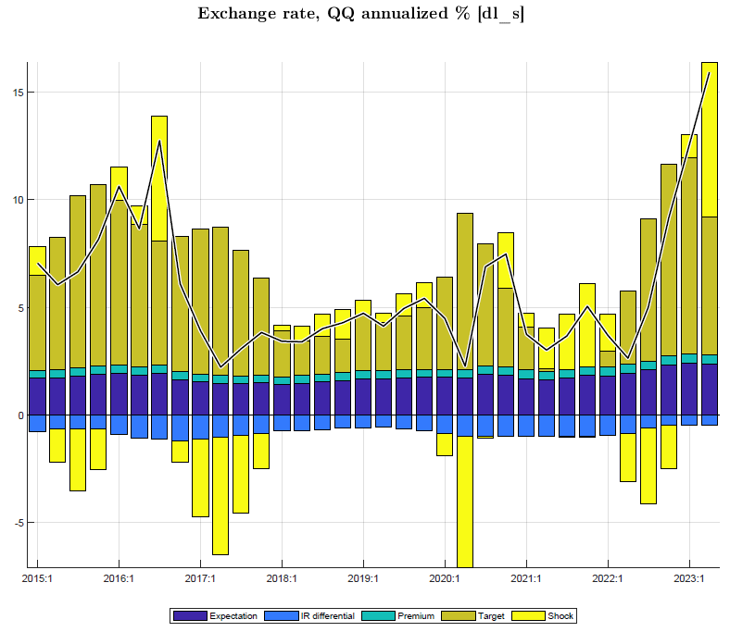

The RER has fluctuated strongly in recent years, around a slight upward path (of less than 1% per year). In 2019 and early 2020, the RER appreciated (-) as nominal depreciation (+) was insufficient to offset core inflation. In the first half of 2020, nominal depreciation was slowed down as imports fell sharply and aid increased in response to the Covid crisis. From mid-2020, the faster nominal depreciation and subdued inflation more than reversed the earlier RER appreciation. However, from late 2021 till end-late 2022, modest depreciation (around 4% annualized) and the surge in core inflation lowered the RER, to well below trend more than offsetting the earlier increase. The acceleration of NER deprecation since late 2022, resulted in a sharp increase in the rate of RER depreciation (Figures 6.3-4).

[add Figure Target exchange rate ?]
Fig. 6.3 RER versus trend RER, q-on-q % change | Fig. 6.4 RER and its components, q-on-q % change

Current macro policy stance and initial condition (to be updated
Following the review of recent macro developments and policies in Section I, this section recapitulates the current macroeconomic policy stance starting from 2023Q4 and the initial conditions for the forecast period 2023Q3 to 2027Q4.

Current cyclical position
- GDP (output) was estimated to have been below its potential or trend level at end-2022 (by an estimated 4%) but this is subject to uncertainty as potential output may have been put on a permanently lower path as a consequence of Covid.
- The real output growth (y-o-y) has recovered after COVID but has been relatively slower for 2023- GDP growth recorded 8.9% and 6.2% for 2023 Q1 & Q2 respectively (the recovery in Q1 was lower growth for Q2 is attributed to a poor performance of agriculture which was affected by May 2023 floods in Rwanda). The GDP growth estimated using supply-demand high frequency indicators (nowcasting) still lower than first two quarters-marked 5.1% and 4.3% for 2023 Q3& Q4 respectively and the average annual projection GDP for 2023 is projected to grow at 6.2% (2 pp lower than actual growth for 2022).

- Headline inflation (as measured by the urban CPI) rose rapidly during 2022 (y-on-y: from 2% in Q4 2021 to 19% in Q4 2022; and period average from 1% in 2021 to 13% in 2022)-the inflationary pressures have been mainly driven by fresh food index due to lower agriculture performance. The quarterly end-of-period inflation (y-o-y) (d4l) grew by 18.4%, 14.1%, 11.9% and 10% for 2023 Q1, Q2, Q3, and Q4 (only Oct 2023) respectively driven by fresh Food and non-alcoholic beverages index. The annual end-of-period and period average inflation growth is projected at 9% and 14.5% respectively.

Fiscal policy stance
- Fiscal policy has in the past mostly focused on composition of government spending (operations, human/infrastructure capital) and debt sustainability, and less on stabilization of output. But under Covid, the fiscal expansion due to mitigating measures (spending on G&S, transfers and subsidies, tax relief)—on average over 2% of GDP during 2019/20─2021/22—contributed to counter the Covid-induced downturn, with an estimated effect on GDP of almost 2% points.

- However, the expansionary stance ended with the fiscal consolidation in FY2022/23 and planned for FY2023/24 which translated into a drop both government demand of G&S and capital investment (directly affect demand) and fiscal impulse-other expenditures incl. direct subsidies (indirectly effect on BC through demand/investment. Such actions should contribute to combat inflation from early 2023 to the medium term. The fiscal consolidation coupled with relative increase in revenue collection observed from 2023/24 to medium term led lower fiscal deficit incl. grants (% GDP) by -6.1% for 2023/24 from -6.4% for 2022/23 and -3% for medium-term. For instance, the total expenditure (% GDP) reduced-driven by a reduction in expenses (18.7% for 2023/24 from 20.6% 2022/2 following 2.9% to 2.7% in compensation of employees) and capital expenditure (net acquisition of non-financial assets & grants to EBUs and LG (9.5% to 9.9%). Transfers (subsidies, social benefits excl. grants to LG & EBUs) reduced to 1.8% for 2023/24 from 2% for 2022/23 and other expenses maintained at 0.8% for 2022/24-2024/25 from 1.2% for 2021/22. The govt fiscal stance-govt demand (consumption & investment) and other expenses (subsides, interest payments and transfers) have gone down for 2022/23 Q3 and Q4 and expected to remain loose for Q1 & Q2 2023/24 which transmit into a lower negative fiscal impulse on the business cycle.

Monetary and exchange rate policy
- The NBR has responded by three modest interest rate increases totalling 2% points to reach 6.5% late Nov 2022, while being mindful of the still incomplete recovery from the Covid downturn and uncertainty about the size of the extent to which GDP is below its potential level.

- Since February 2022, the National Bank of Rwanda (BNR)-Monetary Policy Committee (MPC) has been tightening the monetary policy as a response to inflationary pressures affecting consumers' purchasing power. The MCP revised the policy rate-Central Bank Rate (CBR) to 7% from 4.5% equivalent to 250 cumulative basis points between Feb 2o23 and Feb 2023. For the most recent period, based on the prevailing economic conditions, the MPC decided to raise CBR by more 50 basis points to 7.5 to 7.0 % between August and Feb 2023, to tame inflationary pressures. From August 2023 towards the end-of 2023, the policy rate maintained to 7.5% until further notice due to monthly (y-o-y) inflation maintained a downward trend in 2023 and expected to average around 6% in 2024 and maintained within 2-8% bands for the medium term. However, the monetary policy rate (3 Q0 average) for remains higher/tighter 7.1% for 2023 than 5.2% for 2022 (still even higher than pre-pandemic level)- as results the interbank rate (3 Q0 average) was steered to 7.6% from 5.6% between 2023 and 2022.

- Thus, the IB real interest rate (RIR) in 2022 was strongly negative and the real lending rate (including lending premium of 8-9%) was much below its trend level. But both should increase relatively quickly as nominal interest rate increases to curb down inflation, with a depressing impact on demand. The real interest rate gap has been negative by 4-5% points since 2022Q1 to 2022Q4 attributed to relatively higher inflation but have started picking up during late 2023 (Q1&Q2) and expected to be moderately positive due to maintained BNR policy rate and slowing down inflation outlook. Thus, that reflect a positive lending interest rates which transmit a 4Q₀⁺ negative impulse on final demand (private investment) for 2023 and 2024.

- After the accelerated depreciation of the exchange rate from mid-2020 which—together with subdued inflation—led the RER to increase, depreciation has been modest (around 4% annualized from late 2021 through 2022), perhaps out of concern that faster depreciation would worsen inflation. The nominal (annualized-d4l-s) depreciation started picking up since late 2022 towards 2023 (i.e., 5% for 2022Q4 to14% for 2023Q3)-as results, in real terms, exchange depreciated around end late 2023 due to nominal effective depreciation as high domestic inflation continues to outpace foreign inflation.

- With a surge in inflation in 2022, the real exchange rate (RER) fell below its estimated trend level (by 5-10% around end-2022). But it has increased gradually back to its trend level around end 2023 (6% for Q3), as inflation abates and NBR allows somewhat faster depreciation (a target of around 7% for y-on-y at end-2023), with eventually a transmit a favourable impulse on demand for net exports.

Overall, the modest tightening of monetary policy (average 6.5% 2022-23) (albeit with RIR still below trend levels), the ending of fiscal expansion after 2021/22, and exchange rate policy entailing some overvaluation seem aimed at containing domestic demand and bringing inflation down.

Macroeconomic outlook, end-2023─2026
This section presents the 16 quarter ahead forecast, using model and initial conditions, as updated with data for 2006Q1 through 2023Q2 and with parameters recalibrated (Sections I-II). It first highlights the underlying external and domestic environment assumptions, then sums up the macroeconomic outlook, and lastly provides a narrative for key macro forecast variables. Alternative scenarios are discussed in Section IV.

Forecast assumptions

External environment assumptions (WEO and other sources)
The overall outlook is improving after the Covid-Ukraine crises, but with downside risks (Figure 7).
The world economy is slowing down due to world interest rate increases in response to inflation,
but Rwanda still enjoys a recovery in foreign demand relative to Covid-years 2020-21—with trading partner demand growth at over 4% per year. World food and oil prices likely peaked in the second half of 2022 and are projected to gradually return to their trend levels, though food prices are projected to stay high for several years (Figures 7.1-3).
Figure 7.1-3 External environment (WEO-GAS/ GEE)
World real interest rates are expected to rise from negative in the past decade to positive by 2027 (2% in latest, gpm?), likely transmitting one-for-one to Rwanda’s sovereign borrowing rates.
Trading partners’ CPI inflation (in US$)—subdued at 1.5% p.y. in the past 5-7 years—is projected to return to a more normal level of 3% in the coming years (Figures 7.4-5).

Table 2. Rwanda’s external environment in recent years, y-on-y % growth (unless indicated otherwise)
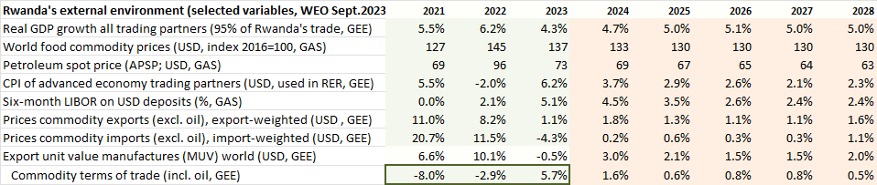
Figure 7.2 External environment (WEO-GAS/ GEE)

Domestic environment assumptions
For the key macro variables, medium-term trends are distilled from historic data and judgment about steady-states. These trends underpin the forecast for potential GDP and final demand components; structural deficit and constituent parts (revenue, demand for G&S and other spending; all in percent of GDP); the trend (neutral) nominal interest rate and trend RIR; and trend RER depreciation rate.
For some macro variables, the forecasts for nearby quarters are ‘tuned’ using near-term forecasts available from other tools, expert judgment, and provisional estimates. E.g., GDP in current and next quarter is set using the now/forecasting tool, the current-quarter CPI and its components are estimated based on latest months’ provisional data. A further domestic environment assumption is that recently observed shocks disappear, e.g., agriculture normalizes, and food and core price shocks are abating.
Other variables are tuned using known or expected policies and judgment. E.g., the NBR’s interest frate or the next-quarter monetary policy committee meeting is guessed (no change) and the exchange rate for the one or two quarters is set based on statements and the program with the IMF.

Fiscal policy assumptions
Fiscal policies are part of domestic environment but as they are known (Budget Law) or expected (MTBF, program with IMF) and are crucial for the forecast, the forward fiscal policy stance is elaborated here. The post-Covid consolidation and winding down of crisis-related spending since 2021/22 continues with the 2023/24 Budget, with a further reduction in the deficit before grants to 10% of GDP in 2023/24, and to 9% by 2025/26 (Table 3). The annual budget goals are quarterlized by dividing by 4 as the treasury plan for 2023/24 is not available.
Table 3. Fiscal policy stance (% of GDP) revise if NA def. cons is used | 2018/19 | 2019/20 | 2020/21 | 2021/22 | 2022/23  est. | 2023/24  budget | 2024/25  PCI | 2025/26  PCI | 2026/27
Deficit (excl. grants, GFS1986) | -10.8% | -13.6% | -14.1% | -14.5% | -12.0% | -10.8% | -9.7% | -7.9% | -6.7%
Revenue (tax and non-tax, excl. grants) | 19.2% | 18.8% | 19.5% | 19.0% | 17.6% | 17.8% | 18.3% | 19.3% | 20.2%
Expenditure G&S (cons & invest) | 24.2% | 25.2% | 26.6% | 25.5% | 23.5% | 22.6% | 22.0% | 21.7% | 21.7%
Other expenditure (subsidies, transfers) | 5.7% | 7.1% | 7.1% | 8.0% | 6.0% | 6.0% | 6.0% | 5.5% | 5.2%

Summary of macroeconomic forecast
As noted above, the forecasts are tuned for nearby 1-2 quarters for output, inflation and components, interest and exchange rate, and fiscal deficit variables. For inflation, forecasts are from model equationa, but with shocks added in the belief that recent inflation shocks not explained by demand pressure (proxied by output gap) will continue for a few more quarters (Table 3). All other forecasts, except external environment variables, are endogenously determined by model relationships.

Table 4 Tuned variables |  | 2023Q3 | 2023Q4 | 2024Q1 | 2024Q2 | 2024/25
GDP now/forecast fr leading indicators | y-on-y growth | 5.2% | 5.4% | -- | -- | --
CPI headline | y-on-y growth |  | 9% |  |  | --
CPI_core shock | q-on-q % ann. change |  | -- | 1% | -- | --
CPI_food shock | ,, |  | 10% | 5% | -- | --
CPI_ener shock (pump price 2023Q3) | ,, | 10% | -- | -- | -- | --
Policy rate (interbank rate) | (½% above CBR) | 8.0% | 8.0% | -- | -- | --
Exchange rate | RWF/US$ | 1189 | 2.7% depr. | -- | -- | --
Fiscal deficit (before grants, GFS1986) | % of GDP | 9.8% | 9.8% | 11.8% | 11.8% | 9.7
The main forecast results are summarized in Table 5.
Table 5. Forecast summary: main indicators
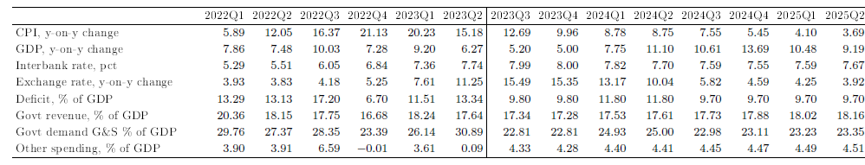

Inflation—after its peak in 2022Q4, is expected to continue declining in 2023 and drop below 5% in 2024Q4 as food price inflation abates (prices drop in late 2024) and core inflation returns to its trend.
GDP—the slowdown induced by recent inflation and restrictive policy response in 2023-25 is expected to continue until 2024Q1. Henceforth, output growth should pick up to above 10% until early 2026, helped by gradually less restrictive monetary and fiscal policies (Figures 8-9).
Figure 8. Summary forecast: output, inflation, RIR and RER
Fig. 8.1 Output growth | Fig. 8.2 Inflation headline |  | Fig. 8.3 Real interest rate | Fig. 8.4 Real exchange rate
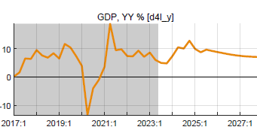 | 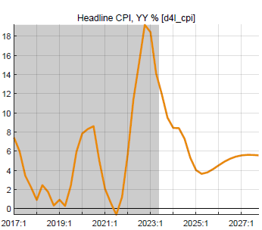 | 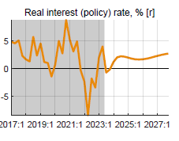 |  | 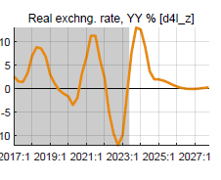
The temporary above-trend growth for two years from mid-2024 is mostly driven by private consumption and return to normal of government demand.
Figure 9. Summary forecast: main drivers of growth (Y-on-Y % and % of GDP)
Fig. 9.1 Private consumption | Fig. 9.2 Gov demand for G&S | Fig. 9.3 Budget deficit excl grants | Fig. 9.3 Exports
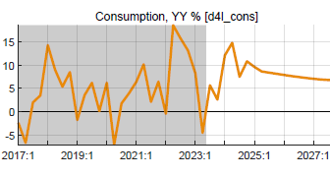 | 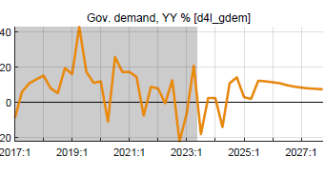 | 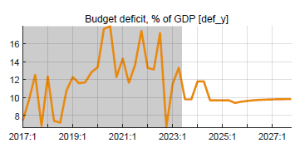 | 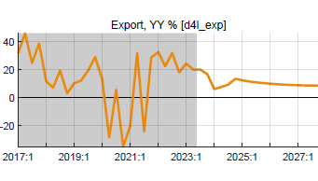

Macroeconomic forecast narrative

Output (GDP) and cyclical position
The y-on-y growth of output (GDP) is expected to remain sluggish at 5% in 2023Q4 as high inflation and restrictive fiscal and monetary policy response continues continue in 2023 and early 2024. The reduction in budget deficit and government spending translated in a drastic drop in real govt demand as inflation soared in 2022-23.
From mid-2024, output growth should rise to above trend for 10 quarters (10% on average) helped by low RIR interest rates, higher RER, and from 2025/26 the end of post-Covid fiscal consolidation as debt is brought down, and the deficit returns toward the sustainable level of 8% of GDP (5% of GDP including grants). From 2027 onward, output returns to its potential trend growth of 7.5% per year. The latter is assumed unchanged after the Covid crisis, since few production capacities have been permanently lost and business closures were offset by new business openings (check).

2022-24 sluggish growth, driven by:  --consumption recovery from Covid interrupted by Ukraine-war and inflation surge and restrictive policy response  --post-Covid fiscal consolidation with negative fiscal impulse  2024-26 growth above trend, driven by:  --less restrictive fiscal policies as deficit gradually back to (higher) sustainable level and govt demand for G&S back to normal  --exports helped by high RER  2027-… back to trend growth of 7.5%  --there is no indication that Covid has permanently reduced poterntial output and its growth | Figure 9.1 GDP growth and its demand components
Contributions of final demands to growth, weighted with shares in GDP;
consumption (78%) and govt demand (23%) have largest contribution
GDP is estimated to be 5% below potential at end-2023, due to both incomplete recovery from Covid and sluggish growth in 2022-23. Output growth is expected to be a bit faster than trend in 2024-26 as the remaining output gap is reabsorbed by the full recovery of consumption and the gradually disappearing down pull from the post-Covid below-trend government demand.
Figure 9.3 Output-below-potential (negative gap) and its components
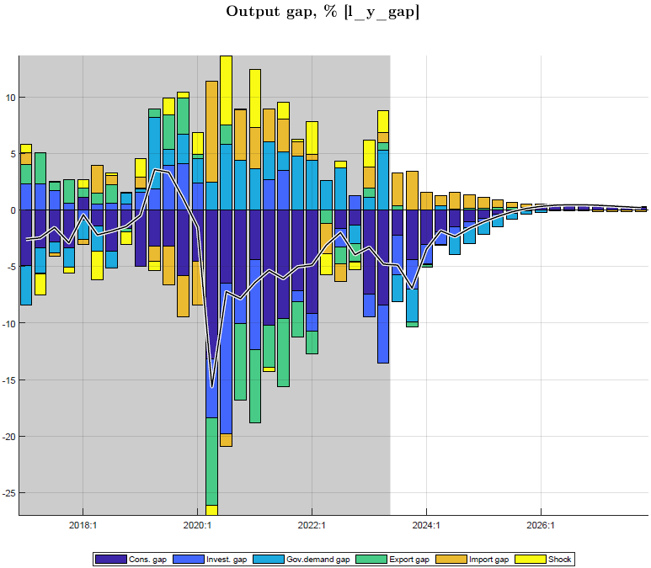 | Negative output gap declines gradually:  --lessening down pull from consumption which goes back to normal  --large initial down pull from reduction in real govt spending  --but gradually disappearing from mid-2024  --exports helped by increasing REER

Private final demands and cyclical position
Private consumption is expected to recover from recent low levels but remains restrained in 2024 by low GDP growth and negative fiscal impulse in 2023-24. After that, as fiscal, and to a lesser extent monetary policy, becomes less restrictive and output growth picks to above-trend, it should return to trend growth in late 2026.
Figure 10. Consumption growth and gap
Fig. 10.1 Consumption growth and trend | Fig. 10.2 Consumption gap and its components
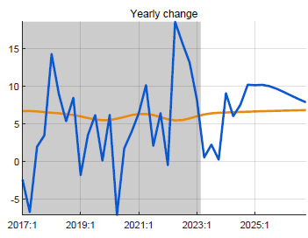 | 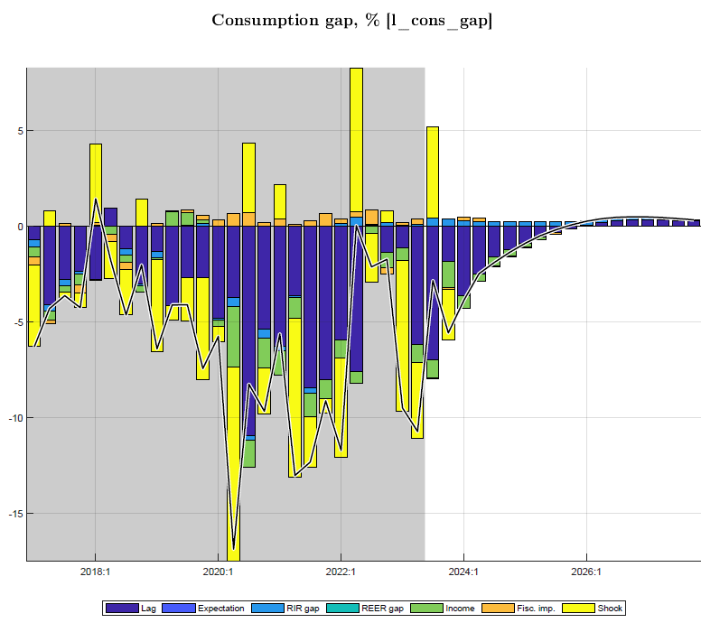
Consumption back to trend, drivers:
--persistence, lagged effect
--expectations
--income, proxied by real GDP
--negative fiscal impulse

The other final demand components--contributing much less to GDP—have their own drivers.
Figure 11. Export gap and components
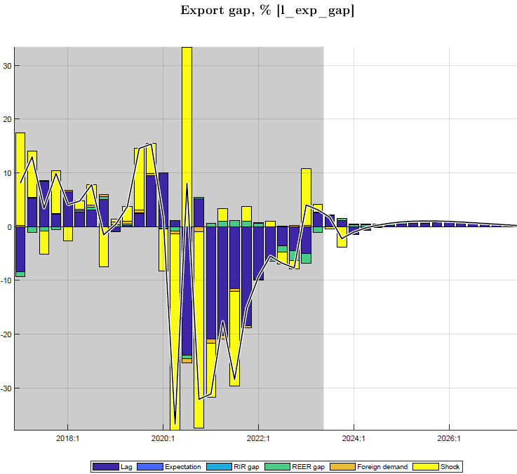 | Exports return to trend level and growth path:  Main drivers:  --persistence (lag)  --expectations  --foreign demand (mainly relevant for tourism, with small coefficient)  --down pull from RER overvaluation disappears

Figure 12. Private investment gap and components
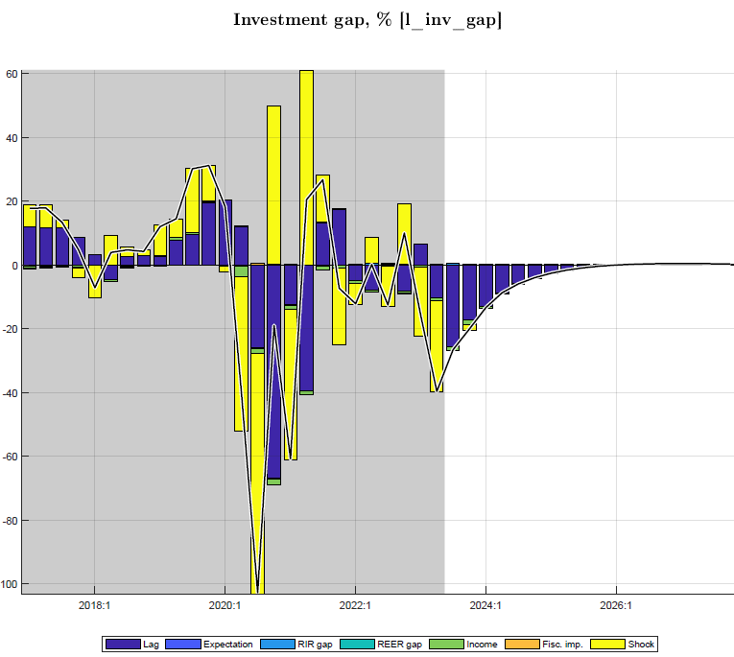 |  | Private investment returns to trend level and growth path  Main drivers:  -- persistence (lag)  --expectations  --real interest rate (RIR) effect is very small  --RER has no effect (zero wight in monetary conditions index)  --small income, effect (proxied by real GDP)  --fiscal impulse has very small effect
Figure 13. Import demand gap and components
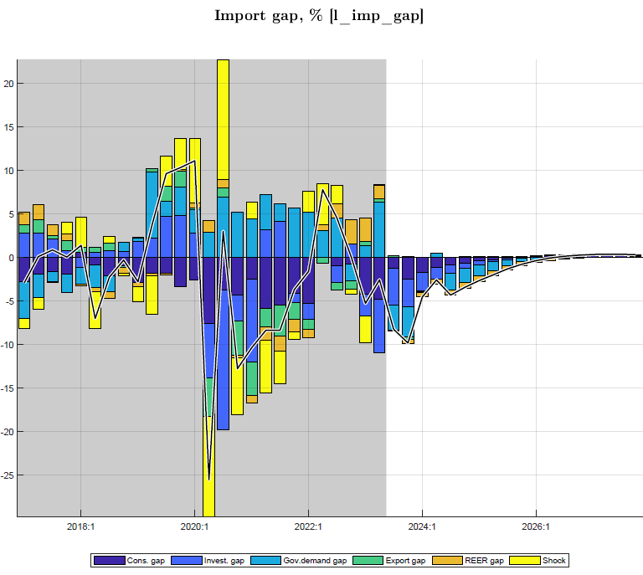 | Import demand (for goods and services) returns to trend level and growth path:  Main drivers:  --final demand components, esp. consumption, govt demand, investment  --RER effect reverses to negative as real depreciation (lower overvaluation) reduces imports

Government demand and deficit components
As noted above, fiscal policies affect output mostly directly as government spends on G&S, and to a smaller extent indirectly as fiscal deficits affect private demand. In the near-term for 2023/24-2024/25, these forecasts are set in line with the government’s program of fiscal consolidation with the IMF, and show a sharp reduction in the deficit before grants and in spending on G&S, as discretionary spending is reversed from Covid-years (Figures 14.1-2). [From 2025/26,…. PCI program….].
Beyond the tuned program years, fiscal deficits and their constituent parts (revenue, spending,…) are forecast to gradually return to the structural levels, as determined by tax policies and sustainable debt-GDP ratios, with a steady-state deficit at 8% of GDP and debt-creating deficit of 5% of GDP.
Figure 14. Government deficit and constituent parts and components, % of GDP
Figure 14.1 Deficit: revenue (-), spending G&S (+), and other spending (+) | Figure 14.2 Structural, cyclical, and discretionary deficit, % of GDP
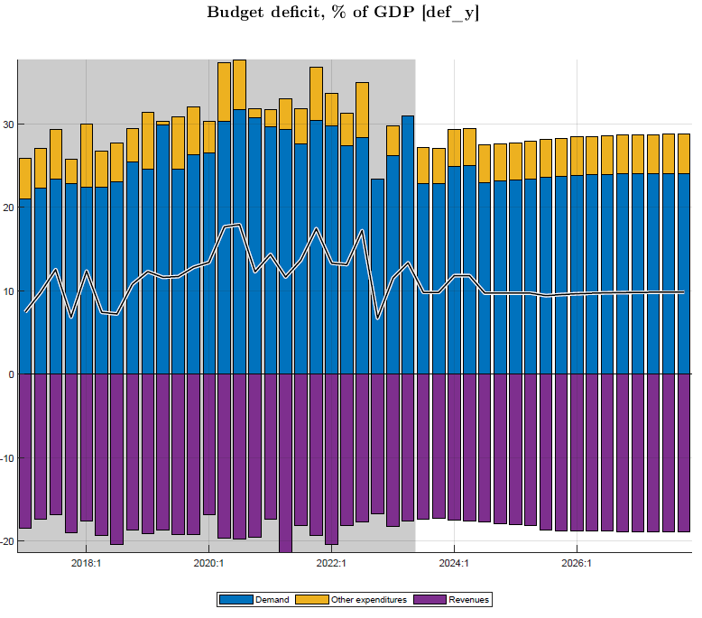 | 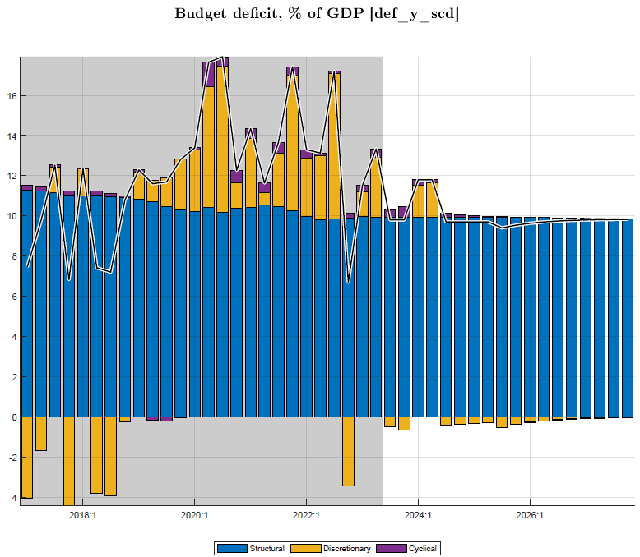

The current fiscal program envisages a reduction in the deficit to 10.8% of GDP in 2023/24 and to 9.7% in 2024/25, well below that in Covid and immediate post-Covid years (averaging 13½% of GDP). This is to be achieved mainly via the ending of crisis-related spending and cuts in govt investment. This translates in a significant reduction in real government demand for G&S, reducing aggregate demand and helping contain inflation. The expansion of govt demand for G&S during Covid is thus reversed from mid-2022 (despite a partial flare-up in 2023Q1-2), and the large negative fiscal impulse is forecast to end by early 2026 (Figure 15).
Figure 15. Government demand: as ratio of GDP and gap vis-à-vis trend
Fig. 15.1 Govt demand for G&S and trend, % GDP  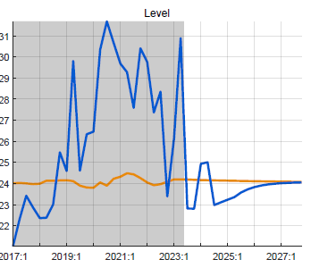 | Fig. 15.2 Govt demand gap (vis-à-vis trend) and drivers, in %  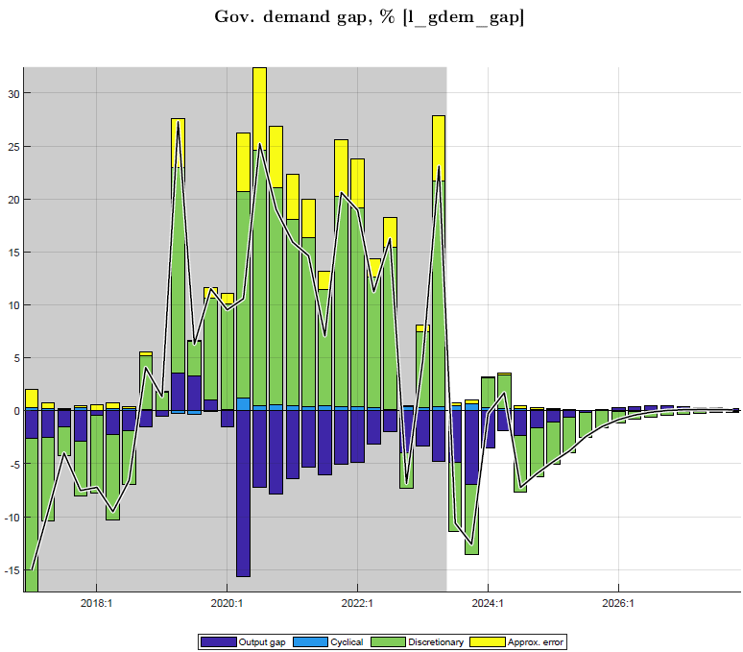

The fiscal impulse turning negative from late 2022 onward and fading out by 2027 (Figure 15.3) not only embodies a below-trend real govt demand for G&S, but also has an indirect albeit small effect on private consumption and investment, and hence on output. The two effects of govt demand for G&S and fiscal impulse on output are shown in Figure 15.4).
The combination of government demand and fiscal impulse are expected to have an important negative impact on output in the short-term, a reversal of the expansionary effect during Covid. A decrease in the deficit by 2% of GDP is estimated to lower real GDP by some 1.6% point, mainly from lower government for G&S (1.2%) and the remainder from lower private demand (0.4%).
 | Fig. 15.3 Fiscal impulse, % GDP  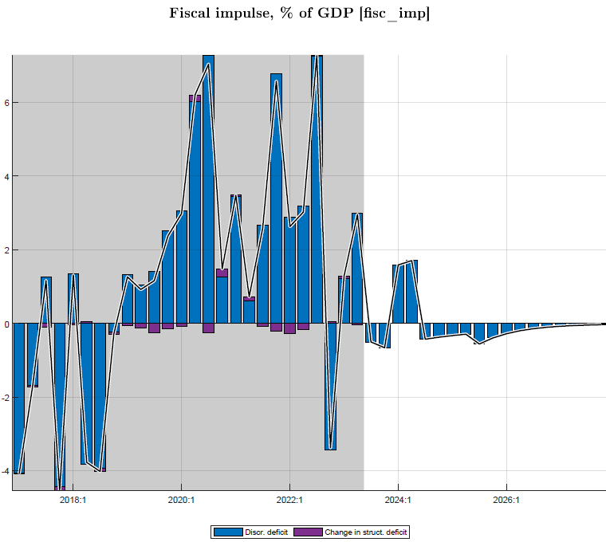 | Fig. 15.4 Fiscal impulse (via private demand) on output vs govt demand effect on output, % GDP

The discretionary deficit is negative, contractionary during 2023-26, mainly from government spending on G&S, which has been its main driver, and it is in this category that there is most room for discretionary policy, much more than for revenue and other spending (transfers and subsidies), except in Covid times for the latter (Figure 16.1). [Problem with gdem data from NA which hugely inflate demand for G&S relative to the Budget, at the expense of (even negative) govt other spending].
The cyclical deficit is positive during 2023-26, mainly from revenue being below trend due to output gap and the lagged adjustment of taxes and fees to the recent surge in inflation.
Figure 16. Discretionary and cyclical deficit 2023-27, % GDP
Fig. 16.1 Discretionary deficit, % of GDP  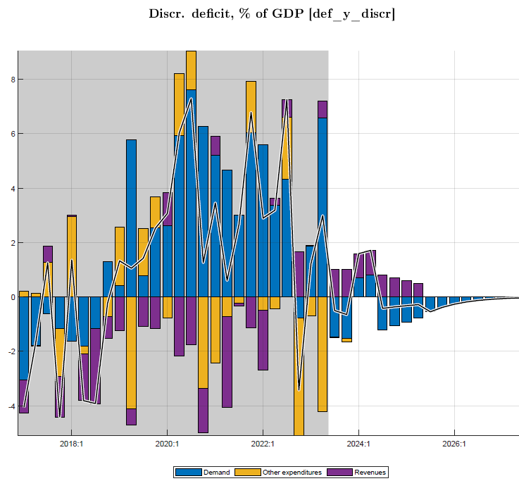 | Fig. 16.2 Cyclical deficit, % of GDP  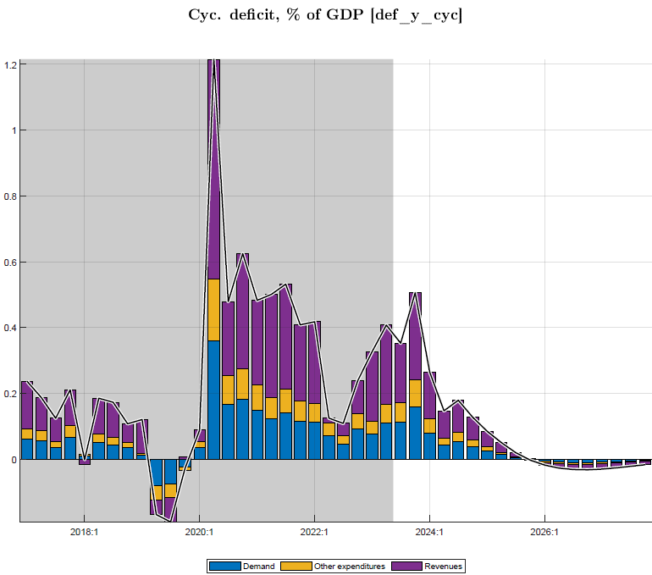

Inflation (CPI)
Headline inflation (having peaked in 2022Q4) is forecast to continue declining and drop temporarily below 5% in late 2025. Q-on-Q annualized inflation is forecast to continue declining in the remainder of 2023 and 2024, as energy inflation drops rapidly (after the 2023Q4 pump price increase) and food inflation drops and some prices fall, helped by lower world prices and improved domestic food supply. This is predicated on recent inflation shocks abating and inflation expectations being countered by NBR action and fiscal restraint, and the absence of further shocks (Table 6).
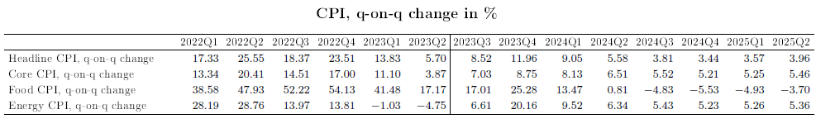

The sharp drop in q-on-q inflation translates into a more gradual drop in y-on-y inflation with the largest contribution coming from the moderation in food prices, even with a short period of falling prices (Figure 17.1-2).
Figure 17.1 CPI headline and its components, % change
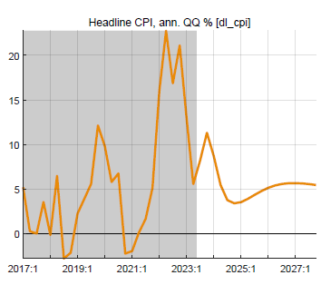 | 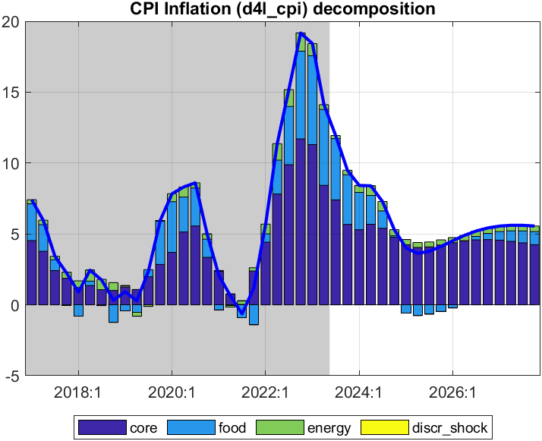

Figure 17.2 Inflation components: core, food, and energy, Q-on-Q annualized, %)
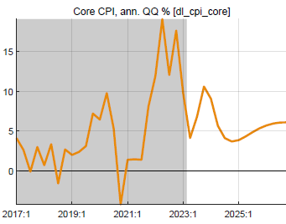 | 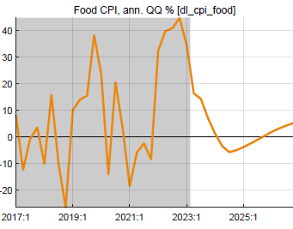 | 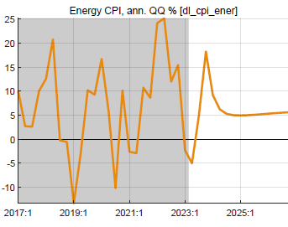

The core inflation forecast of a gradual drop is driven by inflationary expectations, small upward direct effects of import prices and REER (both reflecting exchange rate depreciation), a small downward effect of persisting post-Covid negative output gap, and the gradual subsiding of shocks, tuned to last for only 2023Q4 (Figure 18). Core inflation rate falls slightly below its target of 4.5% in mid-2025 due to the down-pull from remaining negative output gap, then somewhat overshoots 2026-27 (to.5.5%) as a small positive output gap emerges due to fiscal expansion.
Figure 18. CPI core and its drivers, Q-on-Q annualized, %
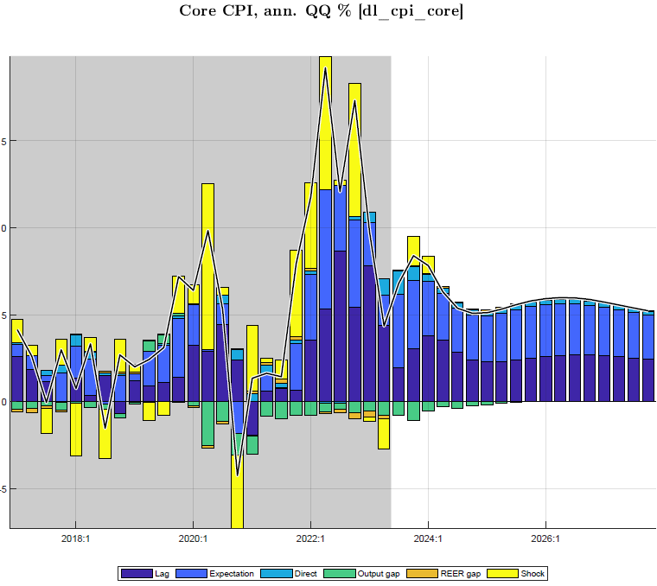 | Main drivers:  --expectations  --persistence (lag)  --direct effect of import prices (+) (foreign prices, exchange rate)  --REER (+) as faster ER depreciation leads to positive RER gap  --output gap (-) exerts small downward pressure

The food inflation forecast of a rapid drop (from a peak in 2022Q4) is mainly driven by declining negative agricultural output gaps (which in part drove prices up from late 2021 to late 2023), as agriculture is expected to normalize. The direct effect of imported food prices is upward (due to ER depreciation), and the indirect effect of the food RER gap is downward (as world food prices are trend). Shocks, still large in 2024Q4 are projected to subside in the near term (Figure 19).
Figure 19. CPI food and its drivers, Q-on-Q annualized %
Figure 19.1 CPI food inflation and its drivers, q-on-q annualized, % | Figure 19.2 Agricultural output gap, %
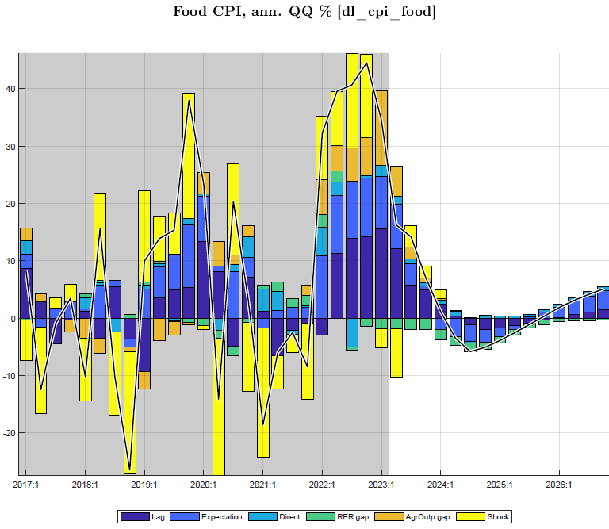 | 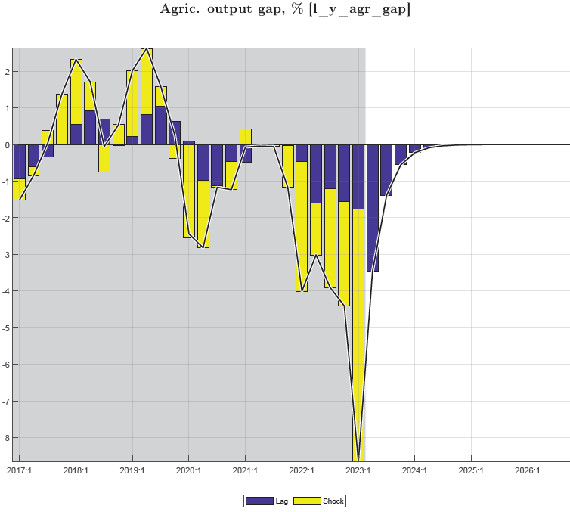

Figure 19.3 Direct effect of imported food prices on CPI food, Q-on-Q %
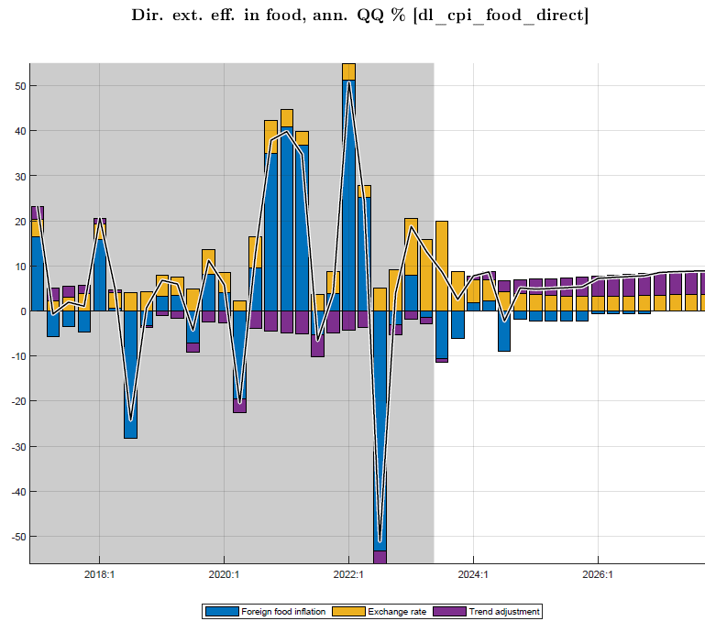 | Main drivers:  --foreign food prices continue to decline or being below trend durin 2023-26  --ER depreciation raises domestic food prices
The energy inflation forecast of a rapid drop (from a peak in 2022Q2) is driven in by the direct effect of imported energy prices which are projected to throughout 2023-27, albeit attenuated by lags in pass-through to domestic prices (including due to offsetting adjustment in fuel excises). The exchange rate depreciation exerts some upward pressure, but little compared to that of foreign energy price drop. Shocks, typically large and especially so in 2022-23, including reflecting the Oct 2023 pump price increase, are projected to disappear from 2024Q1 (Figure 20).
Figure 19. CPI energy, q-on-q annualized, %
Figure 19.1 CPI energy and its drivers |  | Figure 19.2 Direct effect of imported energy prices on CPI energy
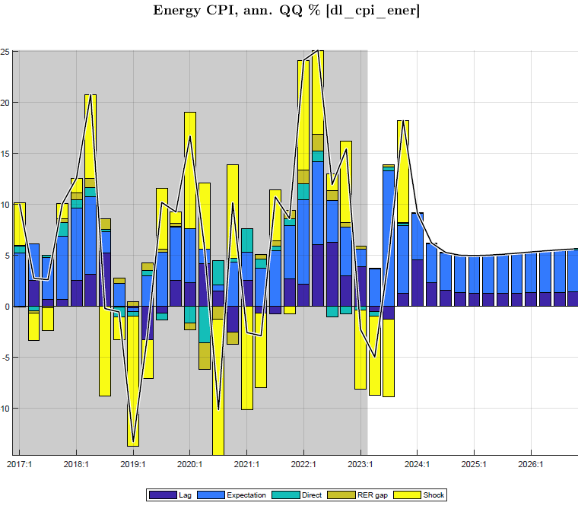 | 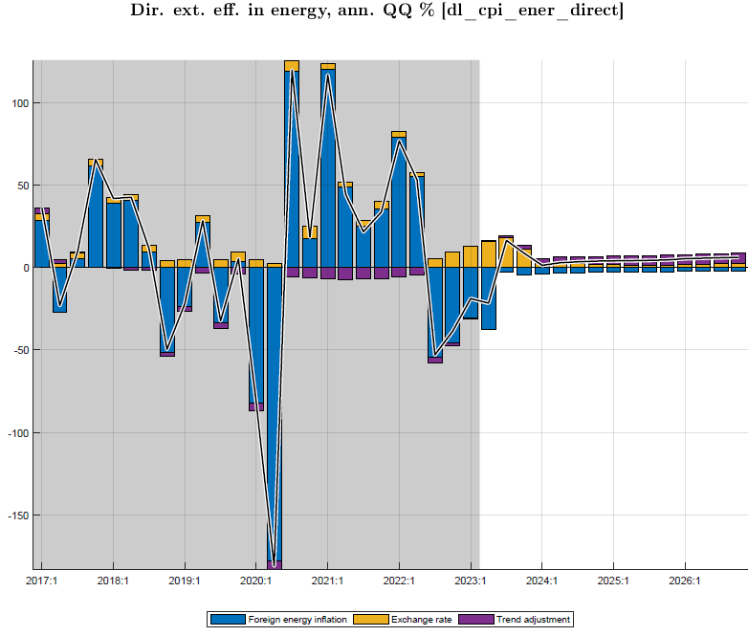

Policy interest rate and real interest rate
The IB rate (or “policy rate” NBR aims to influence with its CBR) is forecast to be gradually lowered from its peak of close to 8% in August 2023 to around 6½% in late 2024 in line with the decline in CPI inflation and output estimated to be still below potential (negative output gap). From 2025, the IB rate is pulled back toward its trend or neutral level of about 7% (Figures 20.1-2).
Figure 20.1 Interbank interest rate, %
--IB rate is tuned for Q4 2023, assuming NBR keeps its CBR unchanged from August 2023
--for 2024, the model’s policy rule forecasts a gradual reduction in IB rates, as inflation drops below the 5% target and a small negative output gap remains
--from 2025, the IB rate moves back up to trend or neutral level (7%), determined by trend foreign RIR (0-0.5%), country risk premium (2%), and core inflation target (4.5%)

Figure 20.2 Drivers of interbank interest rate (policy rule)
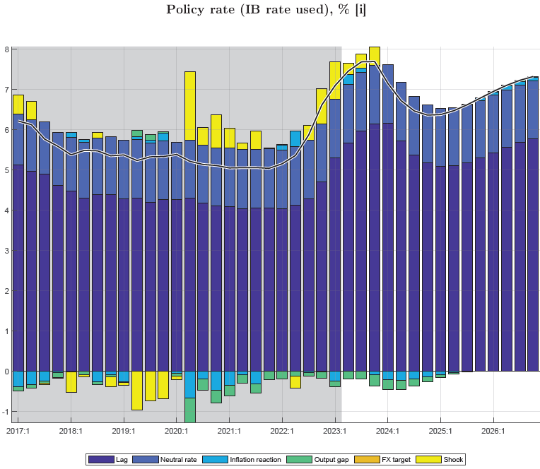 | Drivers of policy rule in 2024:  --expected inflation deviation from target (+)  --negative output gap (-)  --pull from neutral interest rate (6.5-7%) (+)  --gradual interest rate changes, (lagged effect)
The policy real interest rate (RIR) is influenced by NBR’s CBR rate with a view to steering private demand. After a significant drop into negative territory since early 2021 due to high inflation and lagged interest policy response, the RIR is forecast to continue its rise since late 2022, as nominal interest rates rise and inflation eases, but the RIR is forecast to remain below its trend level of 2-2.5%. It is forecast to slightly drop in mid-2025 as inflation flares up temporarily due to demand pressure from fiscal expansion.
Figure 21. Real interest rates, %
Fig. 21.1 RIR (IB rate) and trend, %  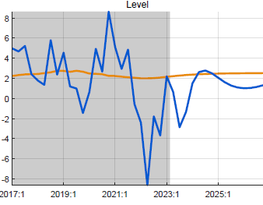 | Fig. 21.2 RIR (IB rate) components, %
The movement in the RIR (as affected by NBR policies) is transmitted to the real lending rate for private demand, calculated as the forward average RIR(IB) over 4 quarters plus a time-varying lending premium (+ 9% points above the IB rate). The real lending rate—above trend during Covid and much below trend, even negative, when inflation surged in 2022-23—is forecast to rise to close to its trend level in 2023, with a depressing (increasingly less positive) effect on private demand.
Fig. 21.3 Real policy and lending rates and trends,% | Fig. 21.4 Real interest rate (RIR) trend, %  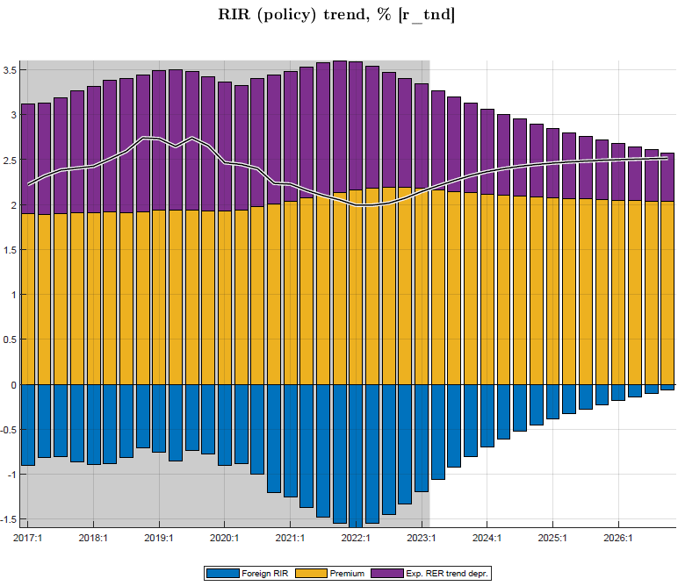

Exchange rate (ER) and real exchange rate (RER)
The forecast reflects NBR’s flexible exchange rate policy and its hybrid rule in practice which is steering the ER to the target ER such that the RER gradually matches the target depreciation rate. In addition, the ER responds somewhat to interest rate differentials (adjusted for country risk premium). The ER is forecast to continue its recent fast depreciation path (annualized 15% for most of 2023), a bit faster than indicated by the target ER, correcting for the recent overvaluation due to high domestic inflation. It then returns gradually to the target ER depreciation rate as explained next.
Fig. 22. Exchange rate “policy rule” and ER target, Q-on-Q annualized, % change
Fig. 22.1 Exchange rate “policy rule” | Fig. 22.2 ER and target
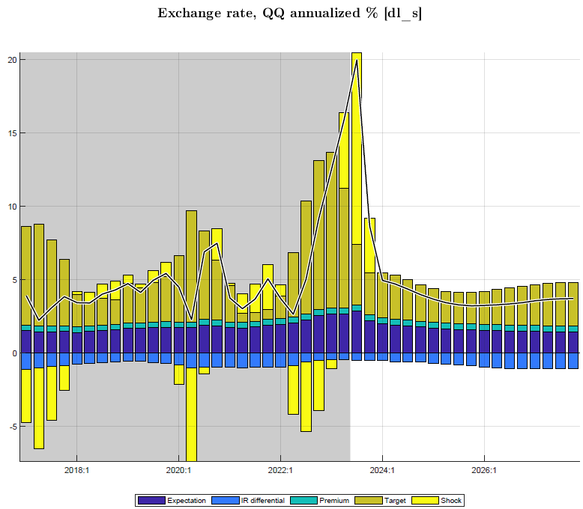 | --ER tuned for 2023Q4 using stated policy of NBR during 2023  --ER steered toward target, so that RER matches trend depreciation rate  --some response to interest rate differentials

The target ER is forecast to descend from its recent faster depreciation rate (as NBR accelerated depreciation during 2023) and return gradually to its trend, which is entirely driven by the difference between target domestic and foreign inflation rates (some 2.5% p.y.) and the trend RER depreciation rate (estimated at 0% p.y.). In addition, the target ER responds to a RER gap (with a negative coefficient) so that the ER is made to adjust faster to overvaluation (negative RER gap as is currently the case) or an undervaluation.
 | Fig. 22.3 Target exchange rate depreciation rate
Drivers ER target:  --domestic-foreign inflation differential (target CPI_core minus trend CPI*), + 2.5%)  --trend RER depreciation rate (0% p.y.) | 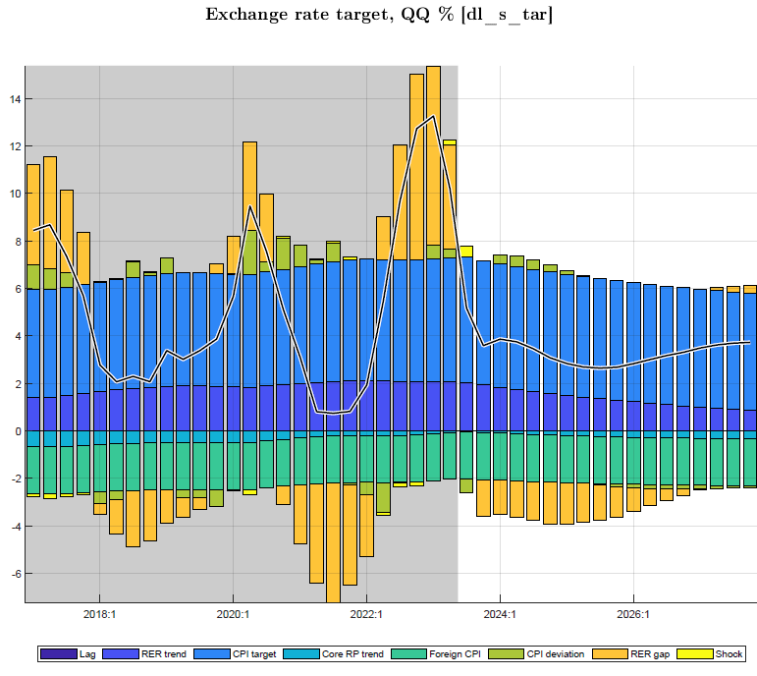

The real exchange rate (RER) is forecast to decelerate the pace of depreciation (from its high in 2023) to return gradually to its (zero) trend level. The RER overvaluation induced by the 2022-23 inflation episode continues to be reduced and is forecast to be zero by 2027. The sharp upward correction in the RER is forecast to favorably affect net exports and demand (reversing a sharp RER decline during 2021-22).
After a somewhat overvalued RER had a downward effect on net exports demand in 2021 when the economy emerged from Covid, it is forecast to rise to its trend level (with some overshooting in 2024) and to affect demand favorably in 2023-24.
Figure 23. Real exchange rate and components, annualized q-on-q, % (vis-a-vis CPI core)
Fig. 23.1 Real exchange rate, trend and gap, in % | Fig. 23.2 Real exchange rate versus trend, in level  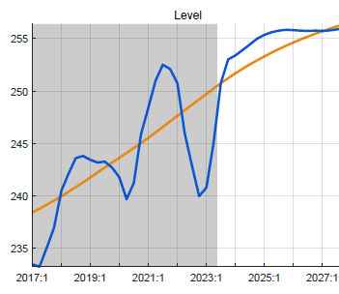
Fig. 23.1 RER, nominal ER, foreign CPI*, and domestic CPI_core, Q-on-Q annualized, in %
Components RER:
--temporarily accelerated nominal depreciation
--domestic core inflation subsides
--foreign CPI* returns to its trend (2-2.5% p.y.)

Summary of policy stance and forecast
This study derives forecasts of key macro aggregates using a gap model, calibrated with data for Q1-2006─Q2-2022: paths for inflation and its components, output, final demands, deficit and its components, and policy indicators (for monetary, exchange and fiscal policies).

The forecasts are conditional on various exogenous assumptions and tuning:
--for external variables (e.g., foreign prices, exchanger rates, demand, interest rates)
--for domestic shocks (e.g., agriculture) and some persistence of shocks in food and core CPI
--for near-term forecasts (nowcasts for GDP, CPI) and domestic NBR policies (interest/exchange rate) and fiscal policies (fiscal consolidation mainly by ending crisis-related spending).

Policy stance. The forecast assumes maintenance of recently increased policy interest rate, faster rate of exchange rate depreciation (both tuned for 2023Q1), and fiscal consolidation (tuned for 2023Q1-2).

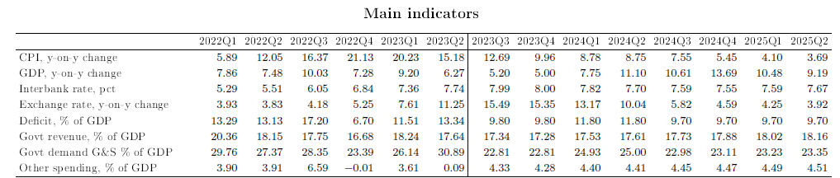
RIR and RER. The RIR is forecast to rise albeit from a low, negative level and exert less upward pressure on private demand. The RER is forecast to rise from a low, negative level and exert less downward pressure on private demand. Both drivers of private demand are influenced by the NBR for output stabilization reasons, while steering them to the trend and steady-state levels (exogenously set). Both should return gradually to their steady states: a 2.5% RIR and 0% annual RER depreciation rate.

Inflation. Headline CPI y-on-y is estimated to have peaked in Q4 2022 and to decline gradually in 2023, as food and energy prices are forecast to continue falling from their peaks in the second half of 2022, inflation shocks prove temporary, and inflation expectations are countered by NBR actions. From early 2024, it should be close to the 5% target. The forecast decline in inflation is faster than in NBR’s projection, mainly because of different take on inflation expectations.

GDP growth—after slowdown in recovery from Covid in most of 2022—is forecast to average 8.5% in 2023-24, with output returning to its potential and growth to its normal trend, estimated 7.5% p.y. The output gap, estimated at -4% at end-2022, should dissipate in 2023-24 when low, albeit rising RIR (despite higher nominal rates) and rising (albeit still low) RER keep up demand.

The fiscal impulse still has a favorable impact on demand and GDP in 2023 but is ending. The fiscal impulse—just over 2% of GDP during FY2020/21─2022/23—is estimated to have countered the Covid-induced output drop, lifting GDP by almost 2%, that is nearly one-for-one.

Supplementary information

Comparison with Macroeconomic Framework projections
An illustrative comparison with Nov. 2022 projection (PCI) shows that annualized QMFM result has—compared to MF:
- lower volatility in final demand components, especially for consumption, investment and imports (MF anomalies…)
- higher average CPI inflation in 2023, more accurate as it traces inflation by quarter
- lower ER depreciation from 2024, as it forecast zero RER depreciation in MT, the MF has real depreciations each year in 2024-26
- higher fiscal deficits return to sustainable level, whereas PCI reduces deficit much below
- correctly reproduced historic data.

Table 3. Comparison annualized QMFM forecast with annual Macro Framework projections (Nov.2022)
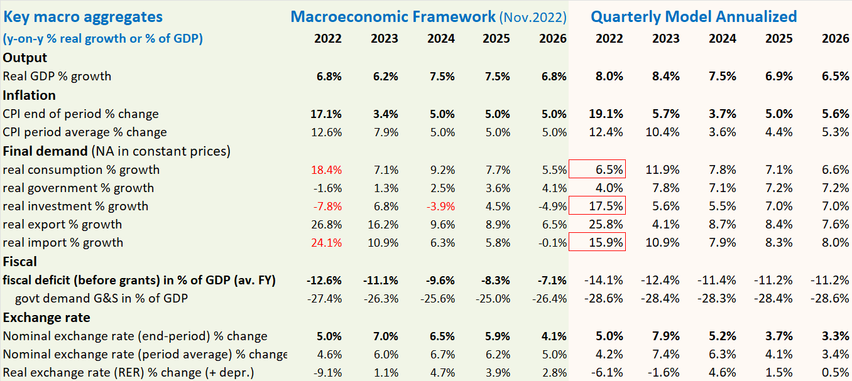

Alternative scenarios and policy responses
This section discusses alternative scenarios to the Baseline underlying the Outlook Forecast Section II.
The forecast model is particularly useful for generating alternative scenarios for comparison with the Baseline (BL). The BL scenario embodies broadly appropriate policy responses to the current external and domestic environment and reflects best judgement on near-term forecast for key variables. But on each front, it is important to explore sensitivity to changes in exogenous variables and domestic policies. This is illustrated in the following scenario.

Scenario of higher foreign food and oil prices in 2023-24
For 2023-24, foreign food and oil prices are set are set at levels on average 25% higher than in the baseline (WEO-GAS price projection in US$, Figure 7 above).
Figure 25.1 Foreign food and oil prices are simulated higher in 2023-24, return to WEO levels from 2025
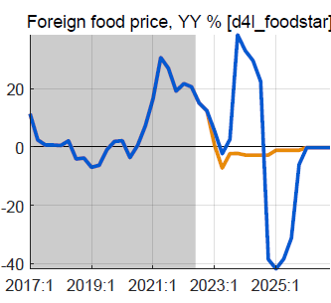 | 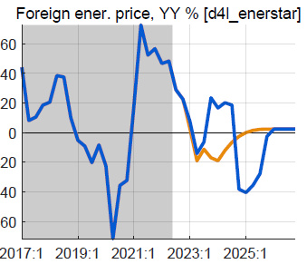
Domestic food and energy inflation remain higher for several quarter, but this is reversed as foreign prices return to the BL from 2025. The effect on upward on headline inflation is small, and also reversed later.
Figure 25.2 Domestic CPI inflation is higher, reflecting import shares in food and energy components
.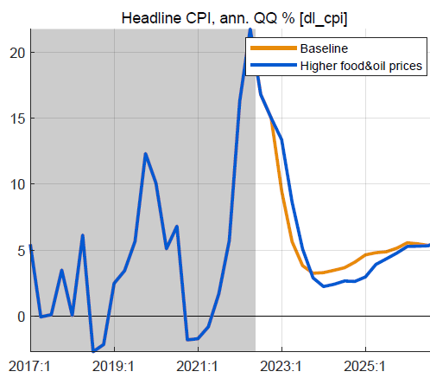 | 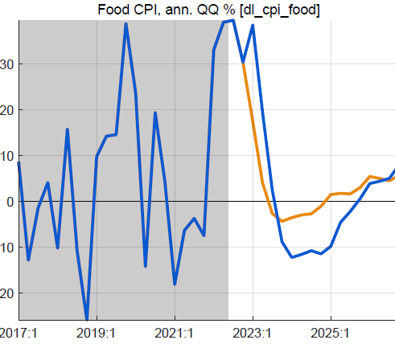 | 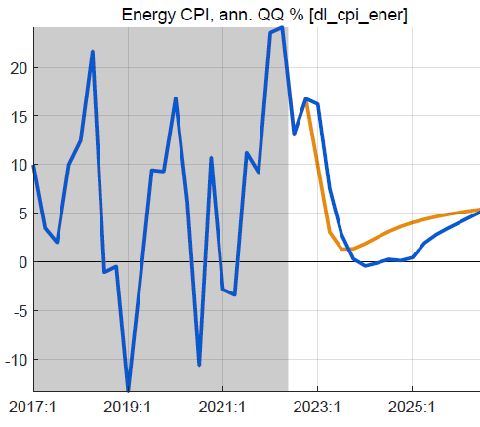

Figure 25.3 Small response policy rate, reversed quickly | ….RIR lower than in baseline | ….tiny positive real output effect, due to RIR but mostly | offset by effect of slight RER appreciation
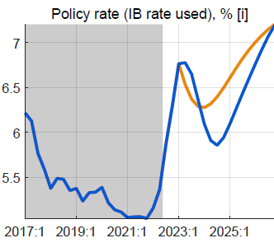 | 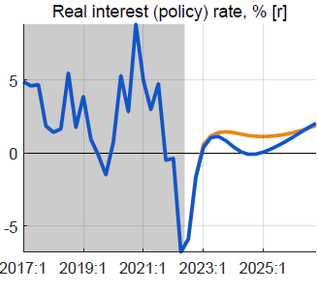 | 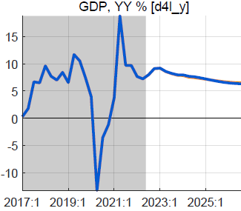 | 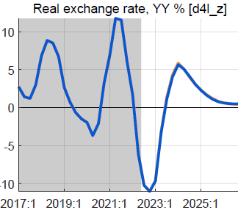
The response of the policy rate in 2023 Q2 is small as the foreign inflation impulses are temporary, and do not affect inflation expectations. The increase relative to BL is reversed in 2024 as the expected inflation becomes lower than in the BL.
With the small increase in the core CPI, the RIR is a bit lower, with a positive impact on consumption and investment. The nominal exchange rate appreciates slightly vis-à-vis the BL when the policy rate is raised; this reverses quickly, but not enough to avoid a slightly more appreciated RER than in the BL, with a negative effect on net exports. The overall impact on GDP is very small, less than 0.2%.

Possible domestic policy response
The scenario focuses on the impact of higher foreign prices and does not incorporate a fiscal policy response. A possible policy response could be temporarily higher budget transfers to protect vulnerable households against higher domestic food and energy prices.

Annex 1. Rwanda Quarterly Macro-Fiscal Model (QMFM) main features
The QMFM builds on the extensive theoretical and empirical literature on FPAS models typically used by central banks but also ministries of finance, and greatly expands the fiscal policy component.
It has the key features of FPAS models (which are simplified New-Keynesian DSGE models):
--founded (albeit loosely) in microeconomic theory, i.e., the neoclassical real business cycle theory and intertemporal optimization for households and firms, with added-on price setting (market power) and adjustment costs, and with forward-looking, model-consistent expectations
--incorporating endogenous monetary and fiscal policies and policy rules, aimed at price stability and output stabilization, with scope for discretion to respond to crisis and shocks
--having four main blocks: for demand, supply (prices), exchange rate, and interest rate (Table A1.1); the QMFM also has a block for fiscal policies and blocks for money and external flows (see below).
Table A1.1: Main macroeconomic variables in Quarterly Macro-Fiscal Model
Dependent variable | Equation: main variables^{1/ 2/} | Data frequency | Source | Latest data
1. Real GDP | 1. Demand-output  Real interest rate, fiscal impulse, | Quarterly | NISR | Q3 2022
1a. Macro demand components  (Cons, Inv, Govt, Exports, iMports) | income, foreign demand,  real exchange rate | Quarterly | NISR | Q3 2022
2. CPI Core inflation (and food, energy, headline) | 2. Phillips curves:  output and RER gaps | Monthly, Q | NISR, NBR | Nov. 2022
3. Exchange rate (RWF/USD) | 3. UIP & move to target ER:  interest rate, foreign interest rate, country risk premium, equilibrium RER change, inflation target, foreign CPI | Monthly, Q | NBR | Dec. 2022
Real exchange rate (affecting  (demand), country premium |  | Monthly, Q | NBR | Nov. 2022
4. Policy interest rate  Interbank (IB) rate used, influenced by NBR’s CBR | 4. Taylor policy rule:  output gap inflation deviation, equilibrium RIR, inflation target | Monthly, Q | NBR | Dec. 2022
Lending rate, real interest rate  (for demand), lending premium |  | Monthly, Q | NBR | Dec. 2022
5. Fiscal deficit, spending G&S, other spending, revenue, grants, debt, interest payments | 5. Fiscal block, auxiliary debt block | Quarterly | MINECOFIN | Q2 2022, budget 2022/23
6. Money demand, reserve money and its components | 6. Auxiliary monetary block | Monthly, Q | NBR | Nov. 2022
7. BoP trade balance, government financing, private financing flows | 7. Auxiliary BoP block | Quarterly | NBR | Q2 2022
1/ In addition to lags, expectations (leads), and exogenous variables.
2/ Most variables are in real terms (constant prices) and seasonally adjusted.
--formulating most macro aggregates in deviation from their trend levels (“gap model”); following shocks and policy responses, variables return to their trend levels, and to exogenous steady states
--allowing structural decomposition of forecast variables by main drivers, and similarly for the past
--distinguishing three Phillips curves, for CPI-core, -food, and -energy, which sum to CPI-headline
--having hybrid rule for the exchange rate, driven by domestic-foreign interest rate differentials and a target ER, determined by trend RER depreciation rate and domestic-foreign inflation rate differentials.
The QMFM has some features that are novel for an FPAS QPM (Table A1.1, items 1a and 5-7):
- distinguishing final demand (FD) components in output; instead of only output gap, it has (private) Consumption, Investment, Government, Export, and Import gaps (the latter from FD import shares)
- incorporating various fiscal policies, thus enabling study of interaction and coordination of fiscal and monetary policies; direct effect of government demand for G&S on output, indirect effect via private demand affected by fiscal impulse (discretionary deficit plus change in structural deficit)
- tracing financing of the government deficit (grants, domestic/foreign borrowing), with an auxiliary debt block tracing debt stocks and interest payments (for target sustainable debt/GDP ratios)
- incorporating auxiliary monetary and balance of payments blocks (money demand, private capital flows, …) which do not feedback into the main model
- deriving macro variables in levels, for comparison with other projection tools.
The thus expanded FPAS is well suited for forecasts and policy analysis by ministries of finance. Like many FPAS and other models, it is more suited for scenarios in deviation from a baseline than for forecasting the baseline itself, since the latter is often tuned for the near-term using expert judgment or econometric time-series model forecasts.
This QMFM has a larger role for fiscal variables than most FPAS models and has several fiscal transmission mechanisms in addition to those of interest rates, exchange rates and expectations; and it captures the interaction of fiscal and monetary policies (Figure A1.1).
The interest rate channel: in the short run, an increase in the interbank rate raises the RIR for lending and deposits, which reduces consumption (as intertemporal substitution leads to higher savings) and investment (as projects become less profitable).
The expectations channel: agents are aware of the CB’s policy rule and response to higher-than-targeted inflation and immediately lower their expectations for future inflation.
The exchange rate channel: an interest rate increase attracts foreign capital and leads to appreciation of the exchange rate, exerting a downward pressure on inflation through lower import prices.
The fiscal channels: an increase in government demand affects aggregate demand directly, and via its impact on discretionary deficit components and fiscal impulse, affects private consumption and investment, indirectly. The discretionary deficit components affecting private demand are revenue and expenditure other than government demand for G&S (i.e., subsidies/transfers), with an effect on disposable income—and hence private demand—like that of revenue, but with opposite sign.

Figure A1.1 Main relationships and transmission mechanisms in Quarterly Macro-Fiscal Model
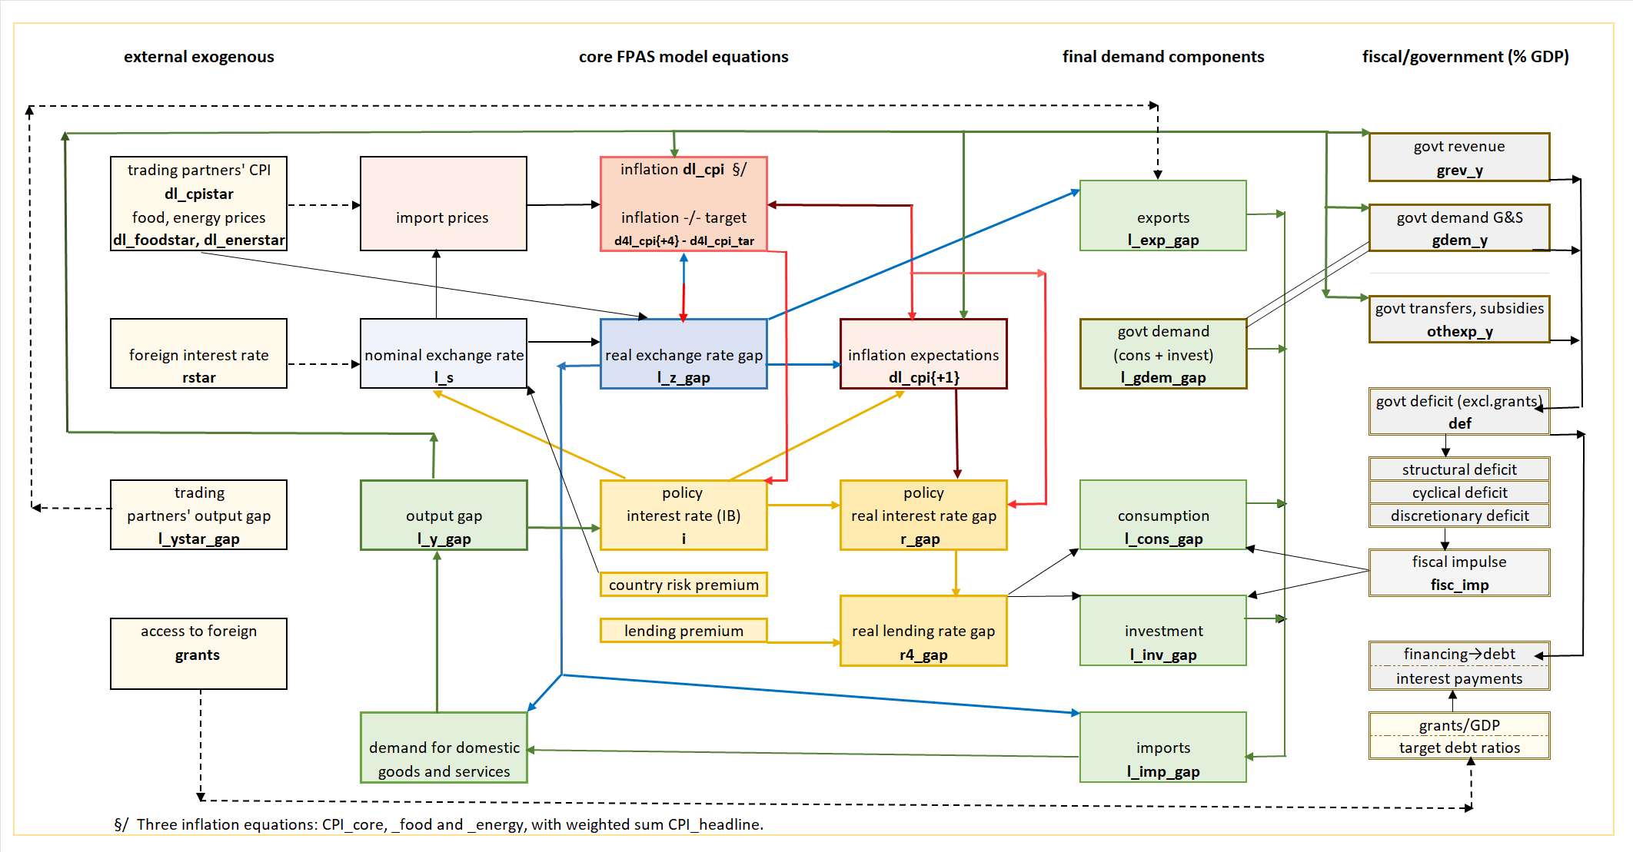

Figure A1.2 Standard FPAS Quarterly Projection Model
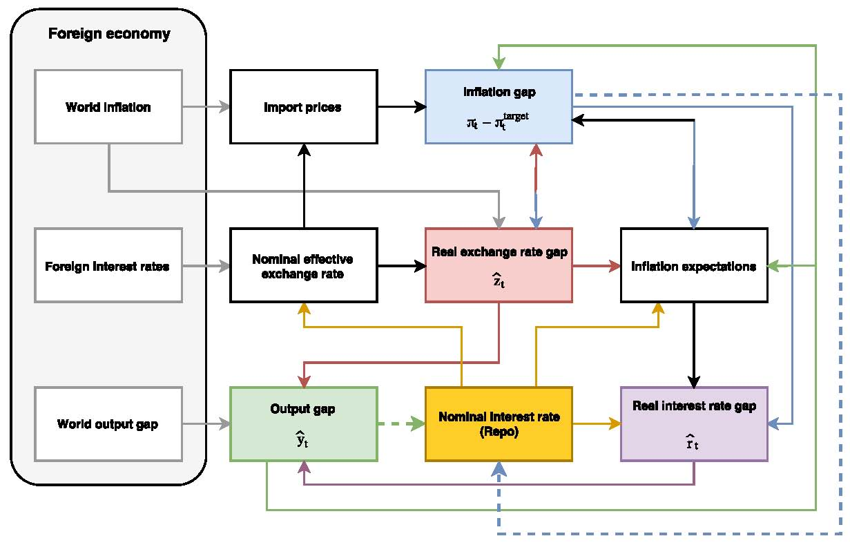
Source: Botha et. al.(2017) The Quarterly Projection Model of the SARB, South African Reserve Bank Working Paper Series, WP/17/01.

Annex 2. Model calibration/filtering using model properties and historical data (2006-22)
This Annex summarizes how the model is calibrated, i.e., parameters are set and subsequently adjusted to ensure (i) plausible responses to shocks (IRF); (ii) a good fit to historic data and reasonable trends and gaps; (iii) accurate historical forecasts; and (iv) plausible future forecasts.
The model’s equation coefficients are set using FPAS studies for Rwanda (NBR, IMF) and other countries in the region, Africa and elsewhere, and information or judgement.. Standard deviations (SD) of shocks are initially set as parameters using other studies. Steady states are set as parameters based on discussion with officials. In the calibration process, four avenues are followed to adjust parameters to improve model accuracy.
Model features. Impulse response functions (IRF) are derived from the model’s reduced form, with each endogenous variable expressed as a function of the coefficients and shocks in all relevant equations. A shock in equation j induces responses in all variables i, and the IRF of variable i to shock j is a function of model parameters alone. E.g., the direct effect of a 1% investment shock should lead to an initial effect on GDP corresponding to the share of investment in GDP times the domestic share of investment. The initial output increase raises consumption and investment, which both raise output in turn, and this is the indirect effect. Further effects are generated as the higher output gap increases inflation, both triggering an interest rate response, with an effect on RIR and consumption and investment, etc. Analysis of the IRF usually leads to adjustment of model coefficients, and this in an iterative way.
Filtering. Unobserved variables (trends and gaps of demands, exchange rate and relative prices) derive from model-wide use of the Kalman filter, which optimizes a criterion function for the set of calibrated SD of shocks over 2006Q1─2022Q2 or latest quarter with available data. After estimating the unobserved and calculating the historic, data SD of variables, gaps, and shocks, each data-based SD is compared with the corresponding calibrated, model SD of the same variable (the latter calculated as function of calibrated SD of shocks and coefficients). In case of large differences, the calibrated, model SD of shocks are adjusted to bring the calibrated, model SD closer to the data-based SD of each variable. Also, judgement about smoothness of trends (e.g., output) leads us to adjust SD. The lower the SD for the shock in a gap equation, the less smooth the trend; and the lower the SD for the shock in a trend equation, the smoother the trend, i.e., the closer to the steady state. E.g., the SD of the growth rates of CPI-core, -food, and -energy were increased to match the data-based SD of these variables as calculated from the filtering outcome.
Historical forecasts. For each quarter t in the historic period, the model uses observation of endogenous variables up to that quarter (taking as given all external variables at their observed levels) to make forecasts for the 8 periods ahead, through t+8. If the historical forecasts for a variable are far from the observed levels (i.e., the RMSE is high)—and not explained by the deviation of actual policies from policy rules—parameters (coefficients and/or SD of shocks) are adjusted. E.g., to improve the poor initial results for CPI-ener and make the forecast less volatile, the coefficients for the direct and indirect import price effects were lowered, that of persistence increased, and that of the expected price lowered.
Forecasts into future. Based on initial forecast results, the assessment of plausibility can lead to adjustment of model parameters. E.g., if the forecast shows a response of the policy rate to the expected inflation{+4Q} deviation from target inflation which is judged too timid, then the coefficient in the policy rule equation may need to be increased. Similarly, to avoid too high volatility in forecast CPI-food and CPI-energy, the coefficients of the direct effect (of foreign prices times exchange rate) were reduced.
Forecast errors. Using the assumed normal distributions of shocks (based on observed past shocks and calibrated distributions of shocks), the errors for each forecast variable-period are calculated.

Annex 3. Recent developments of other final demands and decomposition (2015-23)
Private investment (fixed capital formation and change in inventories) is subject to high fluctuations due to the nature of investment decisions and residual character of inventories in national account estimates. Private investment suffered much early in the pandemic, and a modest recovery in early 2021 was interrupted by another adverse shock in Q4. The decline in investment contributed much to the fall in GDP under Covid. Since then, the negative investment gap (relative to trend) has been resorbed, helped by negative RIR lending rates in recent periods (Figure A3.1). The impact of the fiscal impulse on private investment is considered to be very small.
Figure A3.1 Investment growth y-on-y and trend in %, and invetsment gap and its drivers, 2015-23
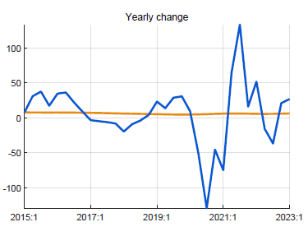 | 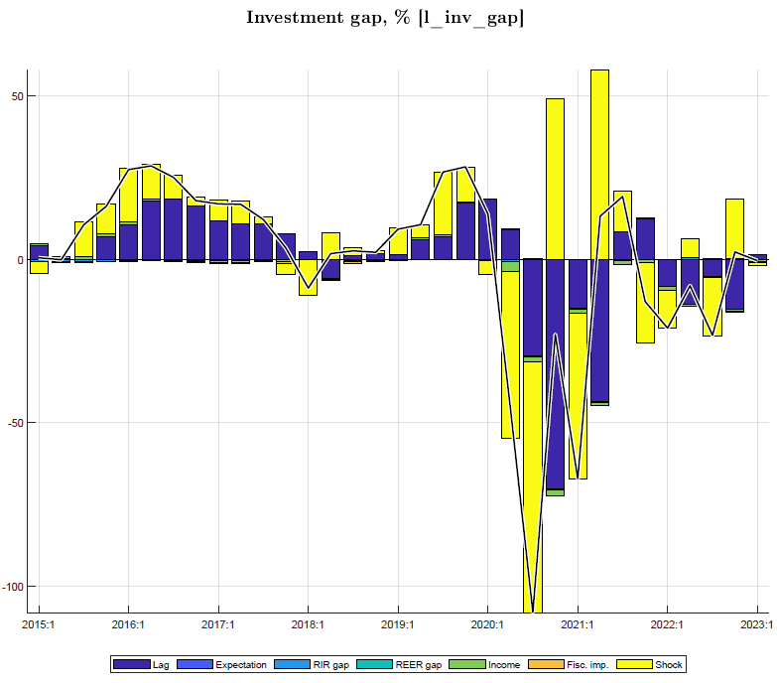
Exports of G&S growth is relatively stable within the year. At the start of Covid in 2020Q2, exports of goods (mineral) and services (tourism) fell sharply and stayed depressed until early 2022, contributing strongly to the drop in GDP. The recovery from the negative export gap took until mid-2022. During Covid, it was helped by an increasing RER, but thereafter hampered by a decreasing RER, albeit with a small coefficient (Figure A3.2).
Figure A3.2 Export growth y-on-y and trend in %, and export gap and its drivers, 2015-23
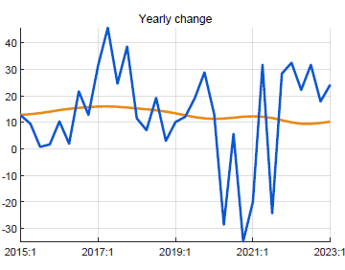 | 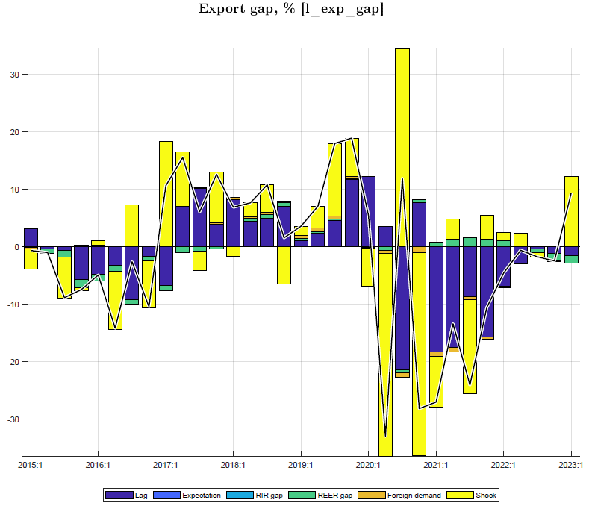
Imports of G&S are the weighted sum of import shares in final demand components (C, I, G, E) with, in addition, a negative effect of the RER (Figure A3.3). The drop in imports during Covid due to both supply constraints and lack of demand, constituted a favorable shift toward domestic demand and offset somewhat the down pull effect from private consumption, exports and investment. Thus, in periods when imports fell relative to trend, there was a positive effect on output (Figure 1.2). The discrepancy shocks reflect the difference between the actual import and GDP shares of each final demand component and the calibrated shares.
Figure A3.3 Import growth y-on-y and trend in %, and import gap and its driver, 2015-23
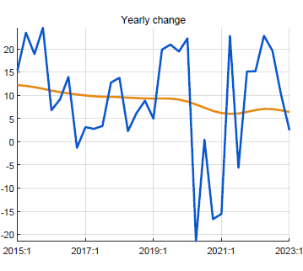 | 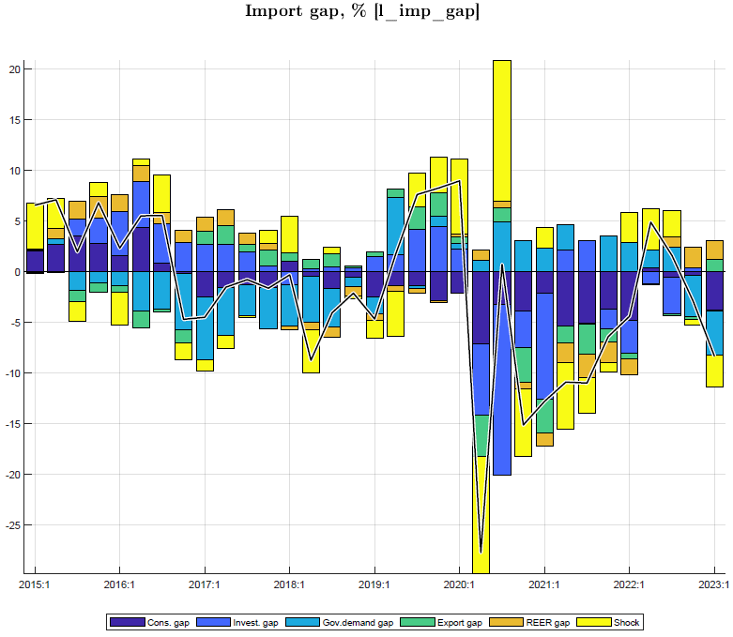

Annex 4. Fiscal block: deficit, fiscal policies, and fiscal impulse in the model
This Annex highlights the key features and concepts used in the elaborate fiscal block, which allows simulating a variety of fiscal policies and analyzing interaction with monetary policies.
The fiscal rule guiding government decisions on deficit (excl. grants, % of GDP) is the “structural deficit trend” which converges to the steady state deficit, consistent with the target debt-to-GDP ratio, taking into account: access to grants, trend real growth rate, trading partner and domestic inflation rates, trend RER depreciation rate, and envisaged share of domestic debt in total debt.
Deficit excluding grants is defined as: government demand for goods and services for consumption and investment (“gdem”) plus other spending (transfers, subsidies, part of Economic Recovery Fund spending, interest payments,...) minus revenue, in % of GDP. The model has equations for the deficit and its components and for gdem (see below).^{1/}
The deficit is decomposed into structural deficit (long-term trend), cyclical deficit (business cycle-induced change in deficit) and discretionary deficit (the remainder, discretionary fiscal policies).
The structural deficit is the trend deficit converging to the steady state defined by the target debt/GDP ratio and is the key outcome of the fiscal rule.
The cyclical deficit—also called (semi-)automatic stabilizer—is positive in a downturn, as government collects less revenue relative to GDP (postponed tax payments, waivers, lower profits,.) and spends more on transfers and subsidies via the social security system, and negative (surplus) in a boom, as revenue/GDP increases and spending/GDP falls. The social security stabilizer is still small in Rwanda but bound to gain importance over time as social spending gets institutionalized.
The discretionary deficit contains remaining ad hoc components of fiscal policies, mainly spending for specific needs, i.e., gdem in deviation from its trend, and some ad-hoc impact on revenue collection (e.g., bandwidth auction, ad hoc tax exemptions,...).
Estimation of deficits and government demand for G&S. Structural and discretionary deficit equations are estimated from filtering historical data, each as function of its lag (AR(1), its steady state (zero for discretionary deficit), gdem, and shocks. The cyclical deficit is a function of output gap.
Similarly, gdem is decomposed into trend and gap, estimated from filtering historical data and also with AR(1). The Kalman filter finds the best decomposition of deficit components and gdem trend and gap (and simultaneously also for all other unobserved variables, incl. output gap), for given or calibrated Standard Deviations of the shocks in the equations.
The fiscal impulse is defined as government discretionary deficit plus change in structural deficit in % of GDP. It is a common measure of the expansionary (contractionary) nature of fiscal policies, capturing both the direct demand impulse toward output (from gdem) and the indirect one (via private sector income affected by transfers/subsidies and taxes, and hence consumption and investment). In this model, the two are separated as follows.
Fiscal policies and fiscal impulse (Figure A4.1)
Fiscal policies in the model affect demand and output in three ways, unlike most FPAS models:^{2/}
--gdem via its own model equation has a direct effect on output, which equals gdem times the domestic demand share (one minus import share)
--the fiscal impulse influences private demand and has an indirect effect on output
--the two effects generate other indirect effects on output as output (income) is among the drivers of private demand, thus generating further demand effects etc. (multiplier).
Figure A4.1 Output gap and fiscal policies, 2017-26 (in % of GDP)
Fig. A4.1
--gdem gap is % deviation from its trend, here weighted with the share of gdem in GDP
--direct effect of gdem is the gap times the share of gdem in GDP times the domestic share of gdem
--fiscal impulse (defined as discretionary deficit plus change in structural deficit) affects private demand
--in Covid years 2020-22, the fiscal impulse has been on average over 2% of GDP, mainly on account of spending on G&S and transfers
--output gap has drivers other than gdem (i.e., consumption, investment, ex/imports), in turn influenced by the RIR and RER
--fiscal expansion under Covid: the direct and indirect effect is estimated to have mitigated the negative output gap by almost 2% of GDP

1/ A newer model version specifies separate equations for gdem, other government spending, and revenue, each with structural, cyclical, and discretionary components. The structural components add up to the structural deficit.
2/ In FPAS models that include fiscal policy, a fiscal stance variable typically appears in the output gap equation, along with lag, lead, and RIR, RER, etc.

Prepared by QMFM team consisting of Evariste Karenzo, Swadiq Ishimwe, Elie Sebagabo, and Arend Kouwenaar.
Annex 1 summarizes the main features and transmission mechanisms of the quarterly model used.
Annex 2 summarizes model calibration/filtering to fit the data; explain macro variables by their main drivers; derive plausible impulse responses of macro variables to shocks; and obtain credible historical forecasts.
CGCF, Gross Fixed Capital Formation in National Accounts; ANFA, Acquisition of Non-Financial Assets in GFS-2014.
In contrast, many studies use the fiscal impulse—defined in various ways—to capture the total effect of the fiscal policy stance on output, i.e., both the direct effect of govt demand for G&S and the indirect effect of induced private demand.
NBR has standing lending and deposit facilities, with rates 1% above and below the CBR. Since June 2020, the actual reverse repo (lending to banks) and repo (deposits by banks) rates have been identical to the CBR. Before that, the actual average rates were mostly in-between the CBR (or its predecessor Key Repo Rate) and the standing and deposit rates, respectively.
The NBR follows an unwritten, modeled interest rate policy rule aimed at meeting the inflation target and minimizing output fluctuations, while utilizing discretion to deviate from the rule.
The neutral rate is driven by foreign real interest rate (3-month US government bonds, currently -1 to 0%, but rising), target core inflation (4.5%), country risk premium (estimated at 2%), and trend real exchange rate depreciation.(currently estimated at 0%).
See the Press Release Monetary Policy Commitee Meeting of November 2023: https://www.bnr.rw/index.php?id=96
In 2023Q3, the headline inflation maintained a downward trend and decreased to 12.7% from 15.2% in 2023Q2 (despite a high increase by 11.2% in month of octber) driven by a drop in core, fresh food and ease in the energy inflation. The inflation in 2024 and outlook will be moderately maintained between 2-8% target. See the Press Release Monetary Policy Commitee Meeting of November 2023: https://www.bnr.rw/index.php?id=96
The interbank rate increased by 7.99% on average in 2023Q3 from 6.05% in 2022Q2 on the back of monetary policy tightening See the Press Release Monetary Policy Commitee Meeting of November 2023: https://www.bnr.rw/index.php?id=96.
The 2023/24 and 2024/25 Budget deficits and spending on G&S have been tuned based on the semester breakdown of annual figures (as the programmed quarterly breakdown is not readily available), hence quarters are the same within the semester.
The sustainable debt-creating deficit is 5% of GDP under assumptions: debt/GDP target of 58% (45% in NPV terms, o/w 10% domestic and 35% foreign debt, grant element of 20%), real GDP growth of 7.5% p.y., trading partner inflation of 2% p.y., and trend RER depreciation rate of 0%. The structural deficit consists of revenue 21%, consumption 13% and investment 11%, and other spending 5% of GDP. The PCI program suggests a sustainable debt-creating deficit of 2% of GDP, for a debt/GDP target of 65% (45% in NPV terms).
Compared to country risk premiums for South Africa (SARB): 3%, Ghana (BoG): 5%.
Unless there was pre-Covid real overvaluation as IMF staff has argued (some 20%). If we built this in in the initial condition, a stronger nominal RER depreciation will ensue for 2024-27.
The Forecasting and Policy Analysis Systems (FPAS) for use by Central Banks were developed by the IMF from the early 2000s. ‘System’ refers to the combination of a quarterly projection model (QPM), a time-series based now/forecasting tool, other satellite models (e.g., fiscal, labor market,..), and policy preparation and communication processes.
Many Ministries of Finance use DSGE, incorporating monetary and fiscal policies, for 3-5 year forecasts, especially in EU and Nordic countries (see recent surveys). They have clear advantages compared to macro-econometric models.

